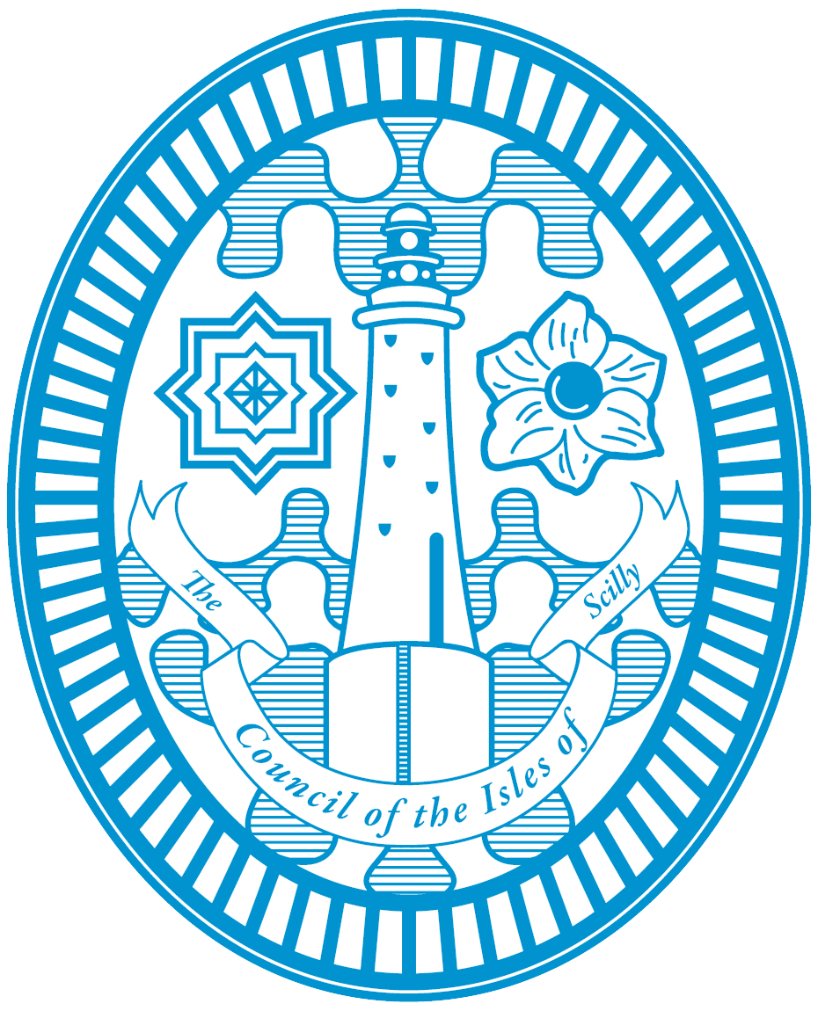
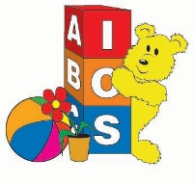
Children’s Centre Registration Form
Council of the Isles of Scilly
The Children’s Services and the Children’s Centre team would appreciate it if you could take a few minutes to complete this registration form, every family is asked to register. This enables us to keep you up to date with activities and services that may be of interest to your family, and monitor, tailor, evaluate and plan future services for the community.

Please use BLOCK CAPITALS to complete this form, thank you.

Parent/Carer Details
Title: |  | Email:
Forename:
Surname: |  | Date of Birth:
Address: |  | Relationship to child:
Postcode: |  | Do you have a disability or special needs? | Please describe.
Contact No.:

Child Details
 | Child 1 Details | Child 2 Details | Child 3 Details
Forename:
Surname:
Date of Birth:
Gender: | Female/ Male | Female/ Male | Female/ Male
Do you consider your child to have any disability or special needs?

Is there anything else you feel we should know?

How we use and store data
I understand that this information will be stored securely. It will be held in accordance with the Data Protection Act 1998 and treated as confidential. The information will be used for monitoring and future planning of Children’s Services and will help to:
- Keep you informed about services and activities
- Monitor the number of children and families engaging with Children’s Services
- Tailor the services offered to meet the needs of the local community and evaluate service provision
- Assess the performance of Children’s Services

I agree to the sharing of information between relevant professionals and services. Children’s Services are legally obliged to share information with other agencies if there are any safety concerns about you or your child(ren).

Photo Consent
- Photographs/ videos may be taken during activities provided by the Children’s Services for use in promotion and/or service evaluation.
- If you give permission for photographs/ video to be take of yourself or your child(ren) during Children’s Services activities, please tick the box.

I have read the information above. I understand and consent to the personal data on this form being stored securely by the Council of the Isles of Scilly.

Signature: |  | Date:

Office use only
Database Updated |  |  | Added to Email |  |  | Sent Welcome email

Please return to:
Children’s Services, Health & Wellbeing Centre, Garn Gwaval, St Mary’s, Isles of Scilly, TR21 0NA
0300 1234 105 childrensservicesemail@scilly.gov.uk

