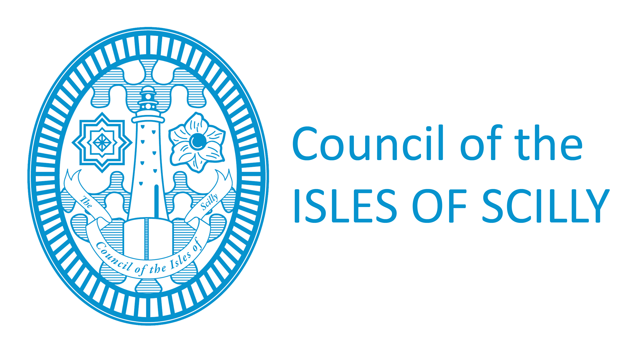
Licensing Department
Town Hall
St Mary’s
Isles of Scilly
TR21 OLW
Tel: 01720 424016/008
Fax: 01720 422202
licensing@scilly.gov.uk

Application for a Personal Licence
PLEASE READ THE FOLLOWING INSTRUCTIONS FIRST

Before completing this form please read the guidance notes at the end of the form.
If you are completing this form by hand please write legibly in block capitals. In all cases ensure that your answers are inside the boxes and written in black ink. Use additional sheets if necessary. You may wish to keep a copy of the completed form for your records.

1. YOUR PERSONAL DETAILS

Title (Please tick)

Mr Mrs Miss Ms Other (please state)…………………..
Surname
Forenames

Previous Names (if relevant) please enter details of any previous names or maiden names. Please continue on a separate sheet if necessary.

Title (Please tick)

Mr Mrs Miss Ms Other (please state)……………………
Surname
Forenames
Date of Birth I am 18 years old or over. (Please tick) |  |  |  |  |  |  | Yes | No

Address where ordinarily resident (We will use this address to correspond with you unless you complete the separate correspondence box below).
Post Town |  |  |  |  | Post Code

Contact Numbers
Daytime
Evening
Mobile
FAX NUMBER

Email address (if you would prefer us to correspond with you by e-mail)

Address for correspondence associated with this application (if different to the address above)

Post town |  | Post code

Contact Numbers
Daytime
Evening
Mobile

Email address (if you would prefer us to correspond with you by e-mail)

2. YOUR LICENSING QUALIFICATIONS
(Read Note 1) Please tick if yes
Please indicate below which one of these statements applies to you:
1. I hold an accredited licensing qualification
2. I hold a certified qualification
3. I hold an equivalent qualification
4. I am a person of prescribed description
If you have ticked either of statements 1, 2 or 3 please provide details of your qualification in the box below (name of qualification, date of issue, issuing body) and please enclose your qualification with your application.
If you have ticked statement 4, please provide evidence that you are a person of prescribed description.
3. PREVIOUS OR OUTSTANDING APPLICATIONS FOR A PERSONAL LICENSE
Note: You may only hold one personal licence at a time. Please tick
Do you currently hold a personal licence? |  | Yes | No
Do you currently have any outstanding applications for a personal licence, with this or any other licensing authority? |  | Yes | No
Has any personal licence held by you been forfeited in the last 5 years? |  | Yes | No
Licensing Authority
Licence number
Date of issue
Date of expiry
Any further details

4. CHECKLIST:
I have Please tick yes
- enclosed two photographs of myself, one of which is endorsed as a true likeness of me by a solicitor or notary, a person of standing in the community or any individual with a professional qualification

- enclosed any licensing qualification I hold or proof that I am a person of prescribed description

- enclosed a criminal conviction certificate or a criminal record certificate or the results of a subject access search of the police national computer by the National Identification Service

- enclosed a completed disclosure of criminal convictions and declaration form (Schedule 3)

- made or enclosed payment of the fee for the application

5. DECLARATION
The information contained in this form is correct to the best of my knowledge and belief.

It is an offence knowingly or recklessly to make a false statement in or in connection with an application for the grant or renewal of a personal licence. (A person is to be treated as making a false statement if he produces, furnishes, signs or otherwise makes use of a document that contains a false statement). To do so could result in prosecution and a fine not exceeding level 5 on the standard scale.
SIGNATURE |  | DATE

NOTES

1. Licensing qualifications
Licensing qualifications are dealt with in section 120(8) and (9) of the Licensing Act 2003.

