
Town Hall
St Mary’s
Isles of Scilly
TR21 OLW
Tel: 01720 424008/016
Fax: 01720 424017
licensing@scilly.gov.uk
Temporary Event Notice

Before completing this notice please read the guidance notes at the end of the notice. If you are completing this notice by hand please write legibly in block capitals. In all cases ensure that your answers are inside the boxes and written or typed in black ink. Use additional sheets if necessary.

You should keep a copy of the completed notice for your records. You must send two copies of this notice to the licensing authority and an additional copy must be sent to the chief officer of police for the area and the Local Authority exercising Environmental Health functions in which the premises are situated. The licensing authority will endorse one of the two copies and return it to you as an acknowledgement of receipt.

I, the proposed premises user, hereby give notice under section 100 of the Licensing Act 2003 of my proposal to carry on a temporary activity at the premises described below.
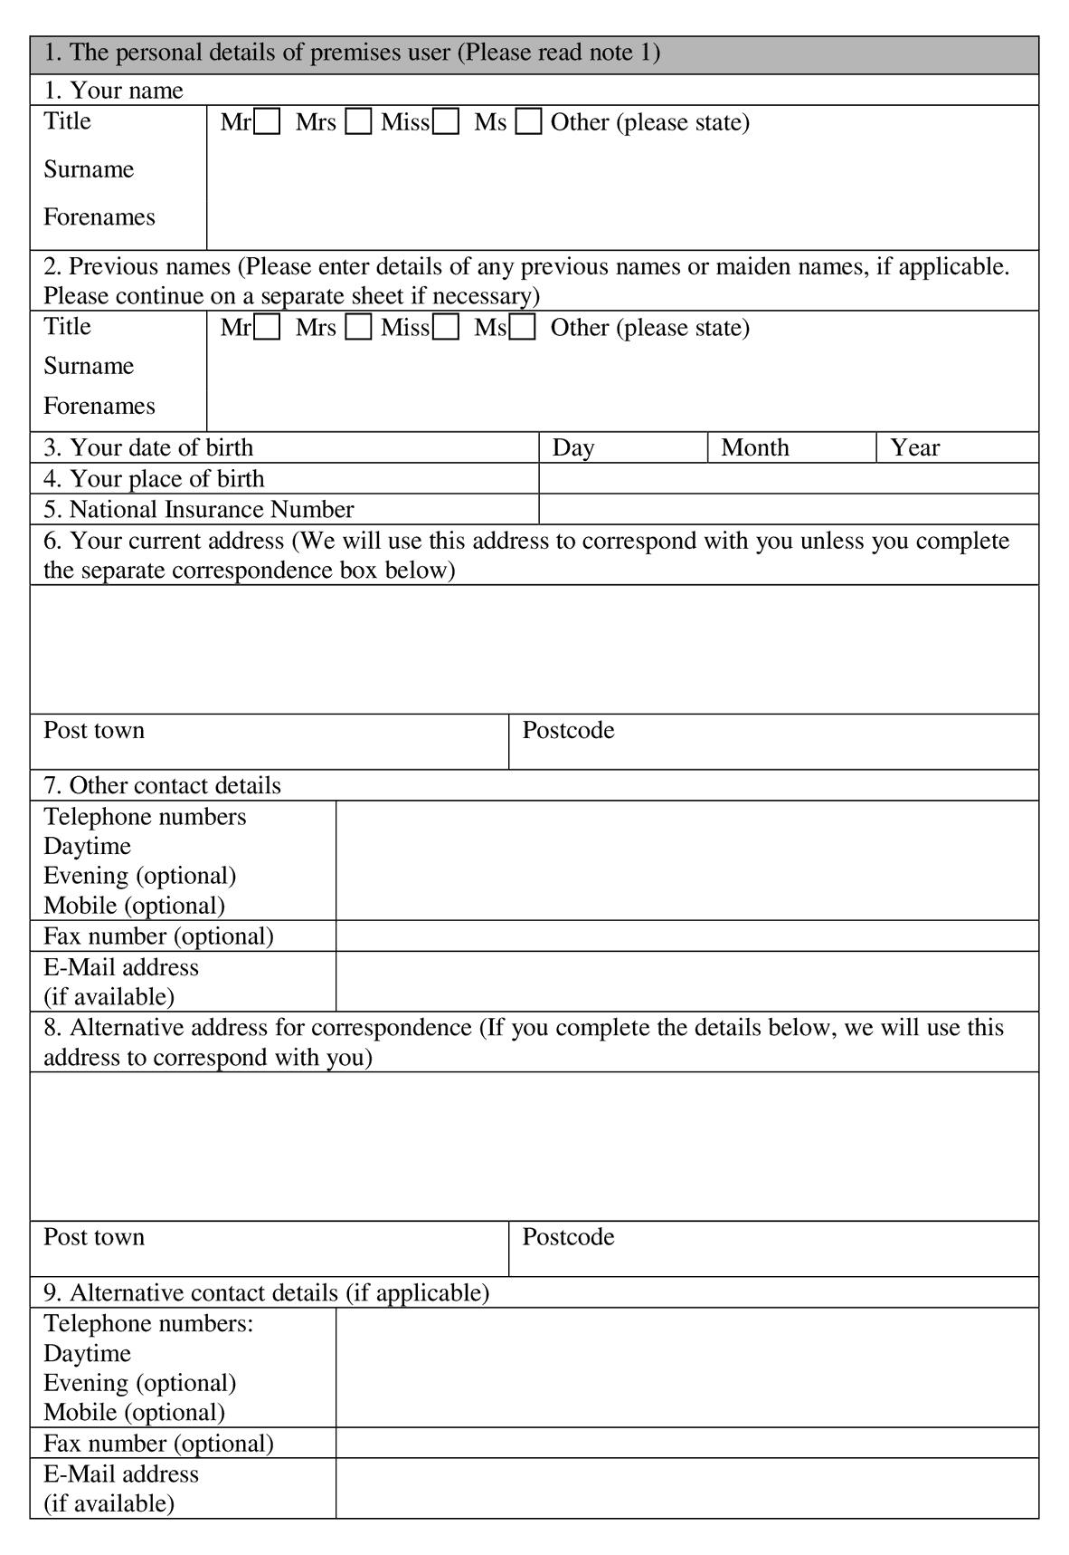
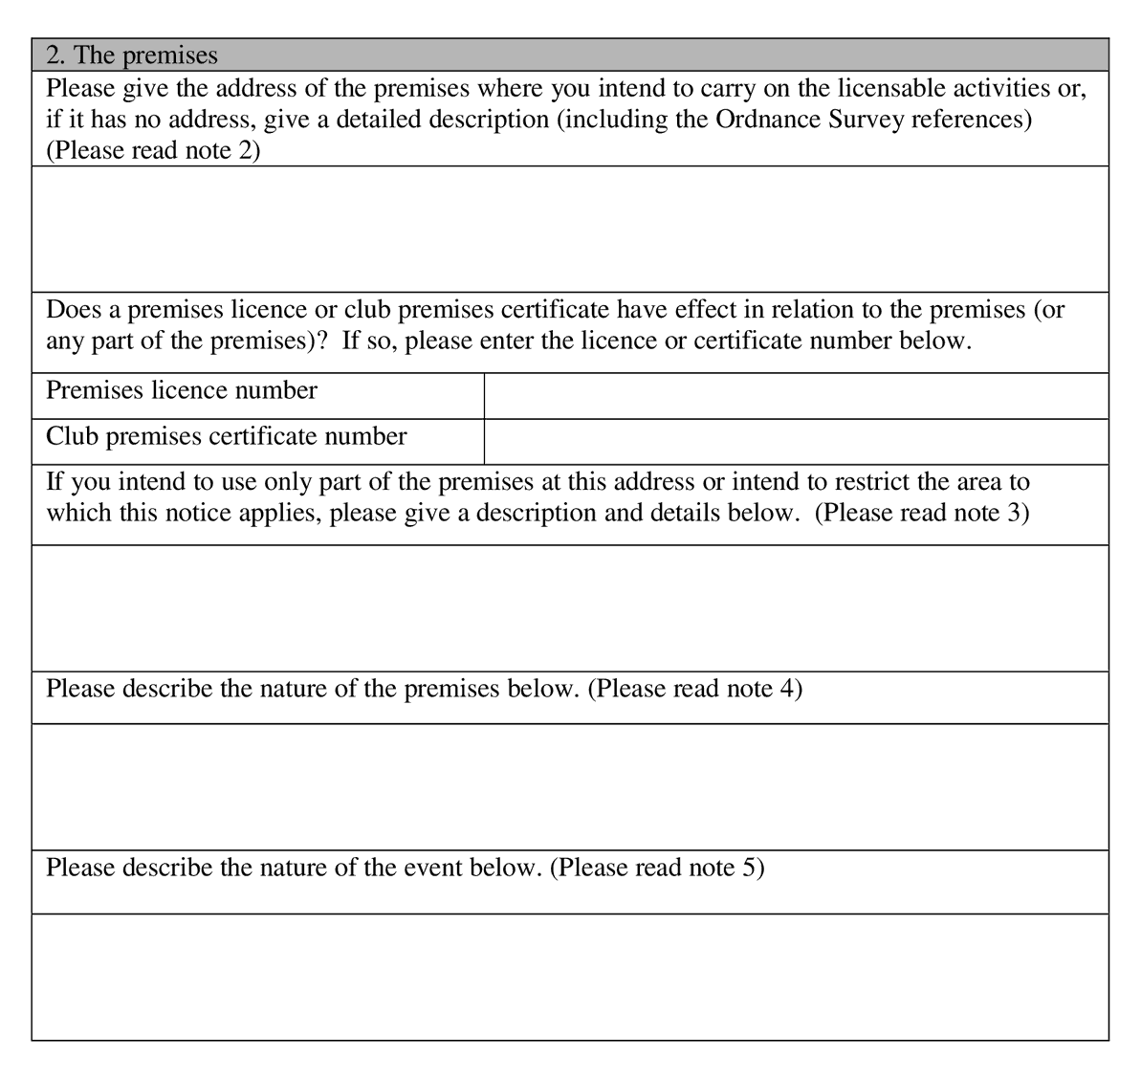
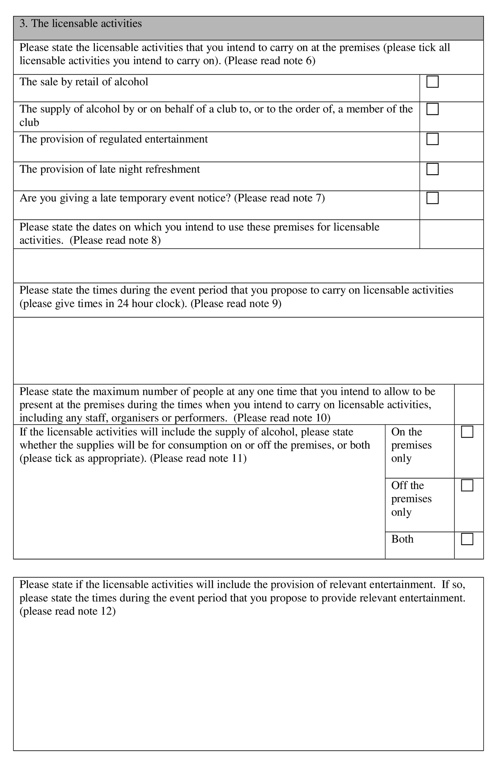

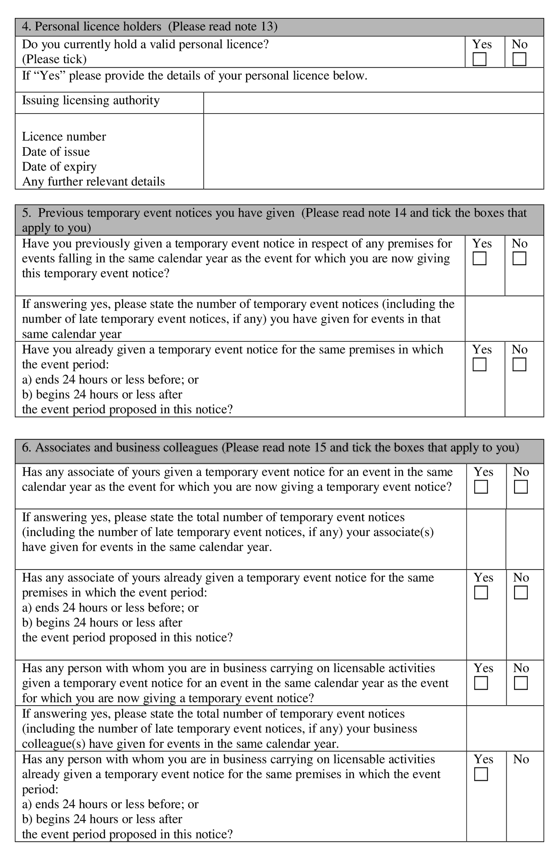
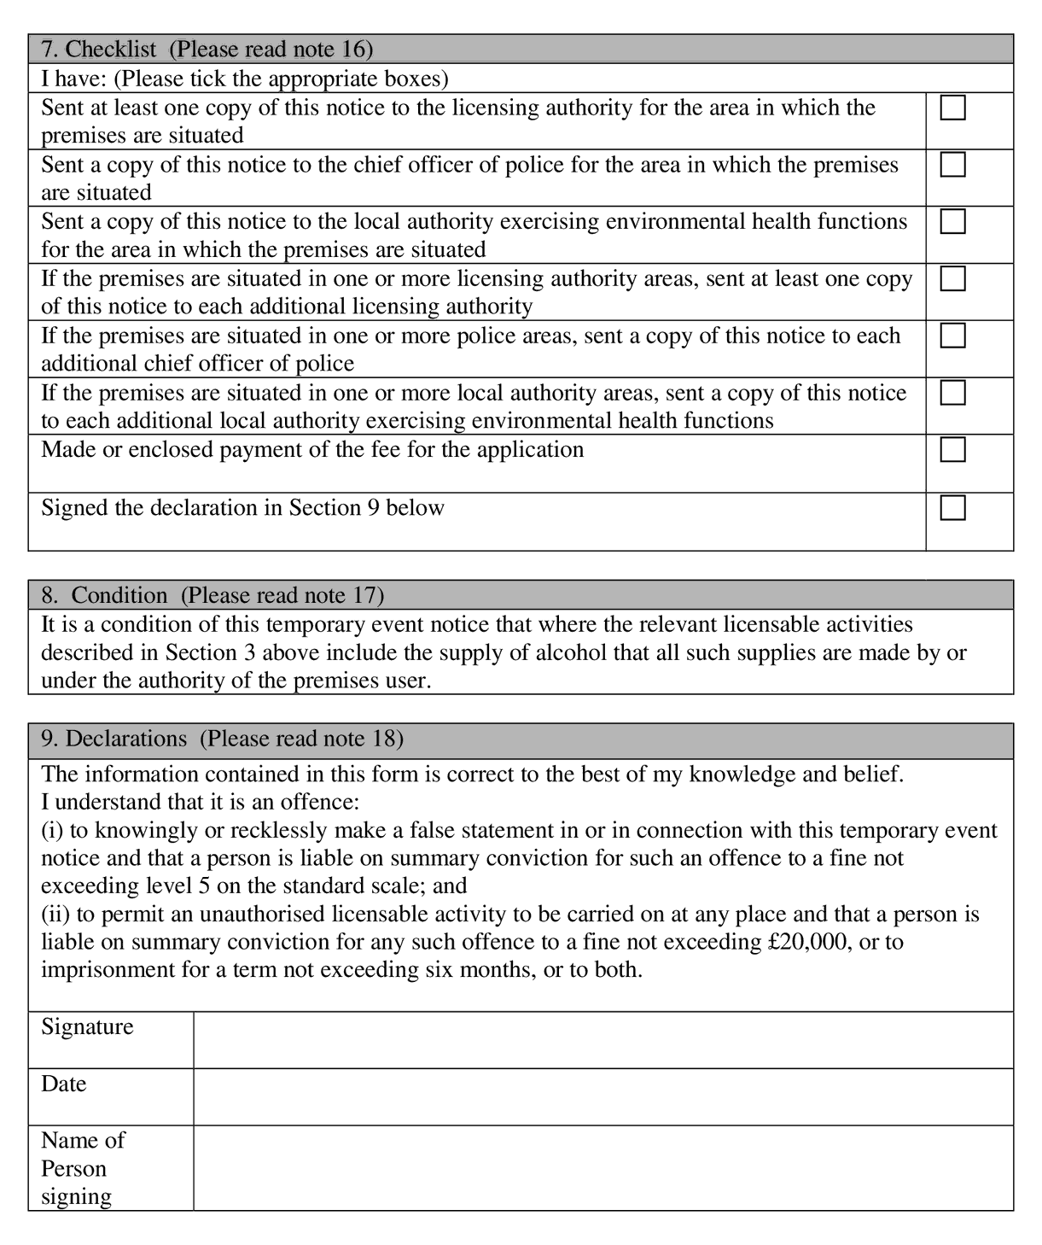
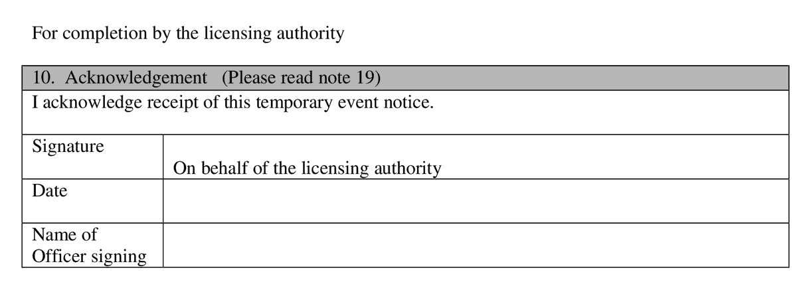

NOTES
General
In these notes, a person who gives a temporary event notice is called a “premises user”.
The police and local authority exercising environmental health functions may intervene on the grounds of any of the four licensing objectives (the prevention of crime and disorder, public safety, the prevention of public nuisance, and the protection of children from harm) to prevent the occurrence of an event at which permitted temporary activities are to take place or to agree a modification of the arrangements for such an event. However, the licensing authority will intervene of its own volition in the cases described below.
First, it will issue a counter notice if there is an objection to a late temporary event notice (see note 7 below).
Secondly, it may issue a notice in relation to its decision to impose conditions on a temporary event notice (see note 2 below).
Thirdly, it will issue a counter notice if the first, second, third and fifth of the limits set out below would be exceeded. If any of the limits below are breached or if a counter notice has been issued, any licensable activities taking place would be unauthorised and the premises user would be liable to prosecution. The limitations apply to:
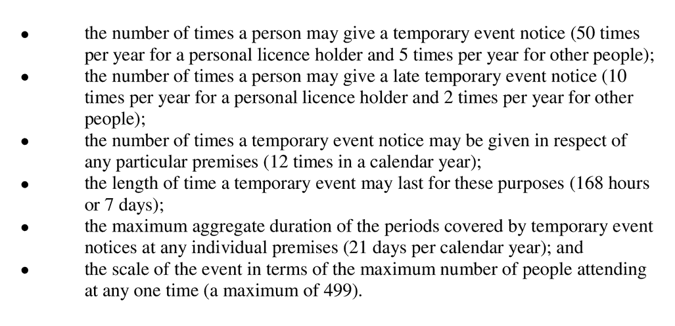
For the purposes of determining the overall limits of 50 temporary event notices per personal licence holder (in a calendar year) and of 5 for a non-personal licence holder (in a calendar year), temporary event notices given by an associate or a person who is in business with a premises user (and that business involves carrying on licensable activities) count towards those totals. The limits applying to late temporary event notices are included within the overall limits applying to the total number of temporary event notices. Note 15 below sets out the definition of an “associate”.
When permitted temporary activities take place, a premises user must ensure that either:
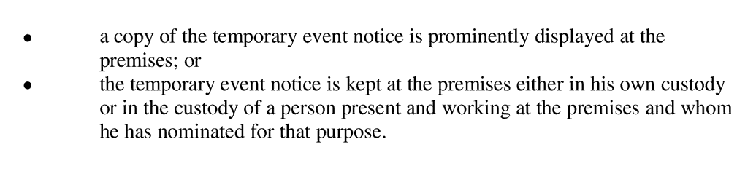
Where the temporary event notice is in the custody of a nominated person, a notice specifying that fact and the position held by that person must be displayed prominently at the premises.
Where the temporary event notice or a notice specifying the nominated person is not displayed, a constable or an authorised person (for example, a licensing officer, fire officer or environmental health officer) may require the premises user to produce the temporary event notice for examination. Similarly, where the nominated person has the temporary event notice in his custody, a constable or authorised person may require that person to produce it for examination. Failure to produce the temporary event notice without reasonable excuse would be an offence.
It should also be noted that the following, among other things, are offences under the Licensing Act 2003:
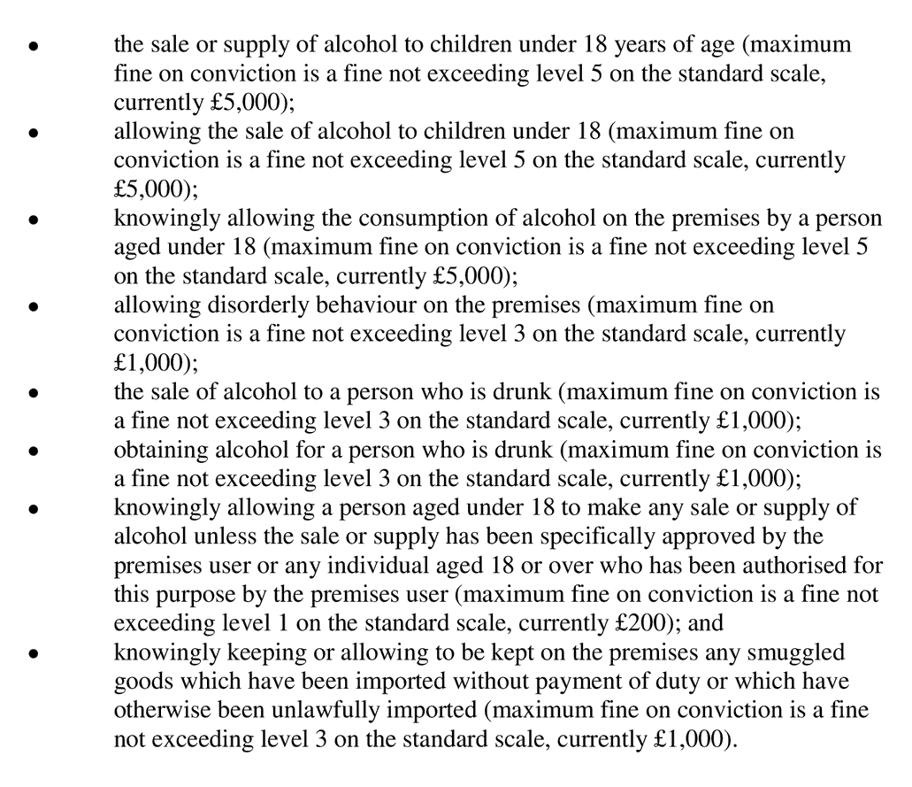
In addition, where the premises are to be used primarily or exclusively for the sale or supply of alcohol for consumption on the premises, it is an offence to allow children under 16 to be present when the premises are open for that purpose unless they are accompanied by an adult. In the case of any premises at which sales or supplies of alcohol are taking place at all, it is an offence for a child under 16 to be present there between the hours of midnight and 5am unless accompanied by an adult. In both instances, the penalty on conviction is a fine not exceeding level 3 on the standard scale, currently £1,000.

Note 1
A temporary event notice may only be given by an individual and not, for example, by an organisation or club or business. The individual giving the notice is the proposed “premises user”. Within businesses, clubs or organisations, one individual will therefore need to be identified as the proposed premises user.
If you include an e-mail address in section 1(7) or 1(9), the licensing authority may send to this the acknowledgement of receipt of your notice or any notice or counter notice it is required to give under sections 104A, 106A or 107 of the Licensing Act 2003.

Note 2
For the purposes of the Licensing Act 2003, “premises” means any place. Premises will therefore not always be a building with a formal address and postcode. Premises can include, for example, public parks, recreation grounds and private land.
If a premises licence or club premises certificate has effect in relation to the premises (or any part of the premises) which you want to use to carry on licensable activities, it is possible that any conditions which apply to the licence or certificate may be imposed on the temporary event notice if certain pre-conditions are met. These pre-conditions are that the police or the local authority exercising environmental health functions object to the notice and the licensing authority decides:
- not to give a counter notice under section 105 of the Licensing Act 2003;
- the conditions apply to the licence or certificate; and
- the imposition of the conditions on the notice would not be inconsistent with the carrying on of the licensable activities under the notice.

Note 3
A temporary event notice can be given for part of a building, such as a single room or a plot within a larger area of land. You should provide a clear description of the area in which you propose to carry on licensable activities. This is important as any licensable activities conducted outside the area of the premises protected by the authority of this temporary event notice would be unlawful and could lead to prosecution.
In addition, when holding the proposed event, the premises user would need to be able to restrict the number of people on the premises at any one time when licensable activities are taking place to less than 500. If more than 499 are on the premises when licensable activities are being carried on, the licensable activities would be unlawful and the premises user would be liable to prosecution. The maximum figure of 499 includes, for example, staff, organisers, stewards and performers.

Note 4
A description of the nature of the premises assists the chief officer of police and local authority exercising environmental health functions in deciding if any issues relating to the licensing objectives are likely to arise. You should state clearly that the premises to be used are, for example, a public house, a restaurant, an open field, a village hall or a beer tent.

Note 5
A description of the nature of the event similarly assists the chief officer of police and local authority exercising environmental health functions in making a decision as to whether or not to make an objection. You should state clearly that the event taking place at the premises would be, for example, a wedding with a pay bar, the supply of beer at a particular farmers’ market, a discotheque, the performance of a string quartet, a folk group or a rock band.

Note 6
The licensable activities are:
the sale by retail of alcohol;
the supply of alcohol by or on behalf of a club to, or to the order of, a member of a club;
the provision of regulated entertainment; and
the provision of late night refreshment.
Please refer to Schedules 1 and 2 to the Licensing Act 2003 for fuller details of the definitions and exemptions relating to regulated entertainment and late night refreshment.
Regulated entertainment, subject to specified conditions and exemptions, includes:
(a)a performance of a play;
(b)an exhibition of a film;
(c)an indoor sporting event;
(d)a boxing or wrestling entertainment;
(e)a performance of live music;
(f)any playing of recorded music;
(g)a performance of dance; and
(h)entertainment of a similar description to that falling within (e), (f) or (g).
If you are uncertain whether or not the activities that you propose are licensable, you should contact your licensing authority for further advice.

Note 7
Late notices can be given no later than 5 working days but no earlier than 9 working days before the event in relation to which the notice is given. A late notice given later than 5 working days before the event to which it relates will be returned as void and the activities described in it will not be authorised.
The number of late notices that can be given in any one calendar year is limited to 10 for personal licence holders and 2 for non-personal licence holders. These count towards the total number of temporary event notices (i.e. 50 temporary event notices per year for personal licence holders and 5 temporary event notices for non-personal licence holders).
If there is an objection from either the police or local authority exercising environmental health functions, the event will not go ahead and a counter notice will be issued.

Note 8
The maximum period for using premises for licensable activities under the authority of a temporary event notice is 168 hours or seven days.

Note 9
You should state here the times during the event period, for example 48 hours, when you intend to carry on licensable activities. For example, you may not intend to carry on licensable activities throughout the entire 48 hour event period, and may intend to sell alcohol between 8.00 hrs and 23.00 hrs on each of the two days.

Note 10
No more than 499 may be on the premises for a temporary event at any one time when licensable activities are being carried on. If you intend to have more than 499 attending the event, you should obtain a premises licence for the event. Your licensing authority should be able to advise you. The maximum figure of 499 includes not only the audience, spectators or consumers but also, for example, staff, organisers, stewards and performers who will be present on the premises.

Note 11
If you indicate that alcohol will be supplied only for consumption on the premises, you would be required to ensure that no person leaves the premises with alcohol supplied there. If such a supply takes place, the premises user may be liable to prosecution for carrying on an unauthorised licensable activity. Similarly, if the premises user gives notice that only supplies of alcohol for consumption off the premises will take place, he/she must ensure that alcohol supplied is not consumed on the premises. The premises user is free to give notice that he/she intends to carry on both types of supplies. For this purpose, the supply of alcohol includes both of the first two licensable activities listed in note 6 above.

Note 12
Relevant entertainment is defined in the Local Government (Miscellaneous Provisions) Act 1982 (“the 1982 Act”) as any live performance or any live display of nudity which is of such a nature that, ignoring financial gain, it must reasonably be assumed to be provided solely or principally for the purpose of sexually stimulating any member of the audience (whether by verbal or other means). Relevant entertainment therefore includes, but is not limited to, lap dancing and pole dancing.
The 1982 Act requires premises which provide relevant entertainment to be licensed under that Act for this purpose. Premises at which there have not been more than eleven occasions on which such entertainment has been provided within a period of 12 months, no such occasion has lasted for more than 24 hours and there has been a period of at least one month between each such occasion are exempt from the requirement to obtain a licence under the 1982 Act. Such premises are likely instead to require an authorisation under the Licensing Act 2003 to be used for such activities as these are a licensable activity (the provision of regulated entertainment – see note 6 above). A temporary event notice may be given for this purpose.

Note 13
The holder of a valid personal licence issued under the Licensing Act 2003 may give up to 50 temporary event notices in any calendar year subject to the other limitations in the 2003 Act. A proposed premises user who holds such a licence should give the details requested.

Note 14
As stated under Note 13, a personal licence holder (issued under the Licensing Act 2003) may give up to 50 temporary event notices (including 10 late notices) in any calendar year. An individual who does not hold a personal licence may only give 5 temporary event notices (including 2 late notices) in England and Wales in any calendar year. A calendar year is the period between 1st January to 31st December inclusive in any year.
If an event straddles two calendar years, it will count against the limits on temporary event notices (12 for each premises, 21 days for each premises, 50 per personal licence holder and 5 for non-holders) for each year. However, only one notice needs to be given.
For the purposes of determining the overall limits of 50 temporary event notices per personal licence holder (in a calendar year) and of 5 for a non-personal licence holder (in a calendar year), temporary event notices given by an associate or a person who is in business with a premises user (and that business involves carrying on licensable activities) count towards those totals. Note 14 below sets out the definition of an “associate”.
If a temporary event notice has been given for the same premises, by the same premises user, and would have effect within 24 hours before the start of the event period under the current proposal or within 24 hours after the end of that period, the temporary event notice given would be void and any licensable activities carried on under it would therefore be unlicensed.
For the purposes of determining whether or not the required gap of 24 hours is upheld, temporary event notices given by an associate or a person who is in business with a premises user (and that business involves carrying on licensable activities) count as if they had been given by the premises user. Note 15 below sets out the definition of an “associate”.

Note 15
An “associate” of the proposed premises user is:
(a)the spouse or civil partner of that person;
(b)a child, parent, grandchild, grandparent, brother or sister of that person;
(c)an agent or employee of that person; or
(d)the spouse or civil partner of a person within (b) or (c).
For these purposes, a person living with another as that person’s husband or wife is to be treated as that person’s spouse.

Note 16
It is a requirement that you send at least one copy of this notice to the licensing authority at least ten working days (or five working days for a late notice) before the commencement of the proposed licensable activities. The authority will give you written acknowledgement of the receipt of the notice. This will be important proof that you gave the notice and when you gave it for the purposes of the Act. Some premises may be situated in two licensing authority areas, for example, where a building or field straddles the local authority boundary. Where this is the case, at least one copy of the notice must be sent to each of the licensing authorities identified, together with the appropriate fee in each case. In such circumstances, you will receive acknowledgements from all the relevant licensing authorities.
One copy must be sent to each of the chief officer of police and the local authority exercising environmental health functions for the area in which the premises is situated at least ten working days for a standard notice (or five working days for a late notice) before the commencement of the proposed licensable activities. Where the premises are situated in two police areas or environmental health areas, a further copy will need to be sent to the further police force and local authority exercising environmental health functions.

Note 17
Under the Licensing Act 2003, all temporary event notices are given subject to a mandatory condition requiring that where the licensable activities involve the supply of alcohol, all such supplies must be made by or under the authority of the named premises user. If there is a breach of this condition, the premises user and the individual making the supply in question would be liable to prosecution. For this purpose, the supply of alcohol includes both of the first two licensable activities listed in note 6 above.

Note 18
It is an offence knowingly or recklessly to make a false statement in, or in connection with, a temporary event notice. (A person is to be treated as making a false statement if he produces, furnishes, signs or otherwise makes use of a document that contains a false statement.) To do so could result in prosecution and a fine not exceeding level 5 on the standard scale.

Note 19
You should not complete section 10 of the notice, which is for use by the licensing authority. It may complete this section as one means of giving you written acknowledgement of its receipt of the notice

