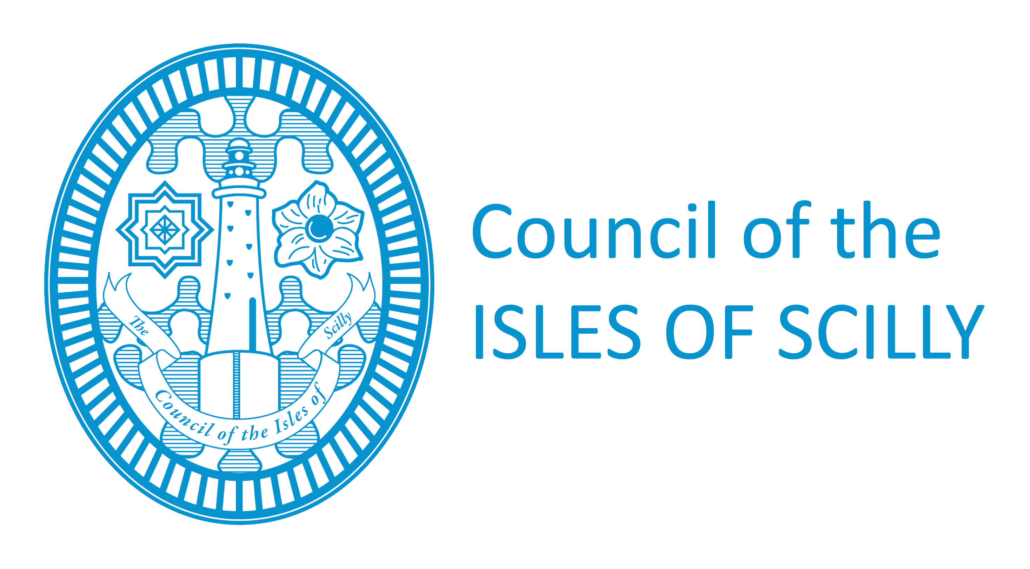
Licensing Department
Town Hall
St Mary’s
Isles of Scilly
TR21 OLW
Tel: 01720 424016/008
Fax: 01720 422202
licensing@scilly.gov.uk

Application for a personal licence

Before completing this form please read the guidance notes at the end of the form.
If you are completing this form by hand please write legibly in block capitals. In all cases ensure that your answers are inside the boxes and written or typed in black ink. Use additional sheets if necessary.
You may wish to keep a copy of the completed form for your records.

1. Your personal details

TITLE Please tick

Mr Mrs Miss Ms Other (please state)
Surname
Forenames

PREVIOUS NAMES (if relevant) please enter details of any previous names or maiden names. Please continue on a separate sheet if necessary.

TITLE Please tick

Mr Mrs Miss Ms Other (please state)
Surname
Forenames
Date of Birth
Nationality
I am 18 years old or over. Please tick |  |  |  |  | Yes | No

ADDRESS WHERE ORDINARILY RESIDENT (We will use this address to correspond with you unless you complete the separate correspondence box below).
Post town |  |  |  | Post code

TELEPHONE NUMBERS
Daytime
Evening
Mobile
FAX NUMBER

E-MAIL ADDRESS (if you would prefer us to correspond with you by e-mail)

Address for correspondence associated with this application (if different to the address above)

Post town |  | Post code

TELEPHONE NUMBERS
Daytime
Evening
Mobile

E-MAIL ADDRESS (if you would prefer us to correspond with you by e-mail)

2. Your licensing qualifications
Read Note 1 Please tick yes
Please indicate below which one of these statements applies to you:
1. I hold an accredited licensing qualification
2. I hold a certified qualification
3. I hold an equivalent qualification
4. I am a person of prescribed description
If you have ticked either of statements 1, 2 or 3 please provide details of your qualification in the box below (name of qualification, date of issue, issuing body) and please enclose your qualification with your application.
If you have ticked statement 4, please provide evidence that you are a person of prescribed description.
3. Previous or outstanding applications for a personal licence
Note: You may only hold one personal licence at a time. Please tick
Do you currently hold a personal licence? |  | Yes | No
Do you currently have any outstanding applications for a personal licence, with this or any other licensing authority? |  | Yes | No
Has any personal licence held by you been forfeited in the last 5 years? |  | Yes | No
Licensing Authority
Licence number
Date of issue
Any further details

4. CHECKLIST:
I have Please tick yes
- enclosed two photographs of myself, one of which is endorsed as a true likeness of me by a solicitor or notary, a person of standing in the community or any individual with a professional qualification
- enclosed any licensing qualification I hold or proof that I am a person of prescribed description
- enclosed a criminal conviction certificate or a criminal record certificate or the results of a subject access search of the police national computer by the National Identification Service
- enclosed a completed disclosure of criminal convictions and declaration form (Schedule 2)
- included a proof of my right to work in the United Kingdom (see note 2)
- made or enclosed payment of the fee for the application

5. Declaration
I am entitled to work in the UK and am not subject to a condition preventing me from doing work relating to the carrying on of a licensable activity. I understand that my licence will become invalid if I cease to be entitled to live and work in the UK.

The information contained in this form is correct to the best of my knowledge and belief.

It is an offence knowingly or recklessly to make a false statement in or in connection with an application for the grant of a personal licence. (A person is to be treated as making a false statement if he produces, furnishes, signs or otherwise makes use of a document that contains a false statement). To do so could result in prosecution and a fine of any amount. It is an offence under section 24B of the Immigration Act 1971 to work illegally.

SIGNATURE |  | DATE

NOTES

Information on the Licensing Act 2003 is available on legislation.gov.uk
from your local licensing authority.

1. Licensing qualifications
Licensing qualifications are dealt with in section 120(8) and (9) of the Licensing Act 2003.

2. Right to work/immigration status:

A personal licence may not be issued to an individual or an individual in a partnership which is not a limited liability partnership who is resident in the UK who:
- does not have the right to live and work in the UK; or
- is subject to a condition preventing him or her from doing work relating to the carrying on of a licensable activity.
Any personal licence issued in respect of an application made on or after 6 April 2017 will become invalid if the holder ceases to be entitled to work in the UK.

Applicants must demonstrate that they have the right to work in the UK and are not subject to a condition preventing them from doing work relating to the carrying on of a licensing activity. They do this by providing with this application copies or scanned copies of the following documents (which do not need to be certified).

Documents which demonstrate entitlement to work in the UK

- An expired or current passport showing the holder, or a person named in the passport as the child of the holder, is a British citizen or a citizen of the UK and Colonies having the right of abode in the UK [please see note below about which sections of the passport to copy].

- An expired or current passport or national identity card showing the holder, or a person named in the passport as the child of the holder, is a national of a European Economic Area country or Switzerland.

- A Registration Certificate or document certifying permanent residence issued by the Home Office to a national of a European Economic Area country or Switzerland.

- A Permanent Residence Card issued by the Home Office to the family member of a national of a European Economic Area country or Switzerland.

- A current Biometric Immigration Document (Biometric Residence Permit) issued by the Home Office to the holder indicating that the person named is allowed to stay indefinitely in the UK, or has no time limit on their stay in the UK.

- A current passport endorsed to show that the holder is exempt from immigration control, is allowed to stay indefinitely in the UK, has the right of abode in the UK, or has no time limit on their stay in the UK.

- A current Immigration Status Document issued by the Home Office to the holder with an endorsement indicating that the named person is allowed to stay indefinitely in the UK or has no time limit on their stay in the UK, when produced in combination with an official document giving the person’s permanent National Insurance number and their name issued by a Government agency or a previous employer.

- A full birth or adoption certificate issued in the UK which includes the name(s) of at least one of the holder’s parents or adoptive parents, when produced in combination with an official document giving the person’s permanent National Insurance number and their name issued by a Government agency or a previous employer.

- A birth or adoption certificate issued in the Channel Islands, the Isle of Man or Ireland when produced in combination with an official document giving the person’s permanent National Insurance number and their name issued by a Government agency or a previous employer.

- A certificate of registration or naturalisation as a British citizen, when produced in combination with an official document giving the person’s permanent National Insurance number and their name issued by a Government agency or a previous employer.

- A current passport endorsed to show that the holder is allowed to stay in the UK and is currently allowed to work and is not subject to a condition preventing the holder from doing work relating to the carrying on of a licensable activity.

- A current Biometric Immigration Document (Biometric Residence Permit) issued by the Home Office to the holder which indicates that the named person can currently stay in the UK and is allowed to work relation to the carrying on of a licensable activity.

- A current Residence Card issued by the Home Office to a person who is not a national of a European Economic Area state or Switzerland but who is a family member of such a national or who has derivative rights or residence.

- A current Immigration Status Document containing a photograph issued by the Home Office to the holder with an endorsement indicating that the named person may stay in the UK, and is allowed to work and is not subject to a condition preventing the holder from doing work relating to the carrying on of a licensable activity when produced in combination with an official document giving the person’s permanent National Insurance number and their name issued by a Government agency or a previous employer.

- A Certificate of Application, less than 6 months old, issued by the Home Office under regulation 17(3) or 18A (2) of the Immigration (European Economic Area) Regulations 2006, to a person who is not a national of a European Economic Area state or Switzerland but who is a family member of such a national or who has derivative rights of residence.

- Reasonable evidence that the person has an outstanding application to vary their permission to be in the UK with the Home Office such as the Home Office acknowledgement letter or proof of postage evidence, or reasonable evidence that the person has an appeal or administrative review pending on an immigration decision, such as an appeal or administrative review reference number.

- Reasonable evidence that a person who is not a national of a European Economic Area state or Switzerland but who is a family member of such a national or who has derivative rights of residence in exercising treaty rights in the UK including:-

- evidence of the applicant’s own identity – such as a passport,
- evidence of their relationship with the European Economic Area family member – e.g. a marriage certificate, civil partnership certificate or birth certificate, and
- evidence that the European Economic Area national has a right of permanent residence in the UK or is one of the following if they have been in the UK for more than 3 months:
(i) working e.g. employment contract, wage slips, letter from the employer,
(ii) self-employed e.g. contracts, invoices, or audited accounts with a bank,
(iii) studying e.g. letter from the school, college or university and evidence of sufficient funds; or
(iv) self-sufficient e.g. bank statements.

Family members of European Economic Area nationals who are studying or financially independent must also provide evidence that the European Economic Area national and any family members hold comprehensive sickness insurance in the UK. This can include a private medical insurance policy, an EHIC card or an S1, S2 or S3 form.

Original documents must not be sent to licensing authorities. If the document copied is a passport, a copy of the following pages should be provided:-

(i). any page containing the holder’s personal details including nationality;
(ii) any page containing the holder’s photograph;
(iii) any page containing the holder’s signature;
(iv) any page containing the date of expiry; and
(v) any page containing information indicating the holder has permission to enter or remain in the UK and is
permitted to work.
If the document is not a passport, a copy of the whole document should be provided.

Your right to work will be checked as part of your licensing application and this could involve us checking your immigration status with the Home Office. We may otherwise share information with the Home Office. Your licence application will not be determined until you have complied with this guidance.

