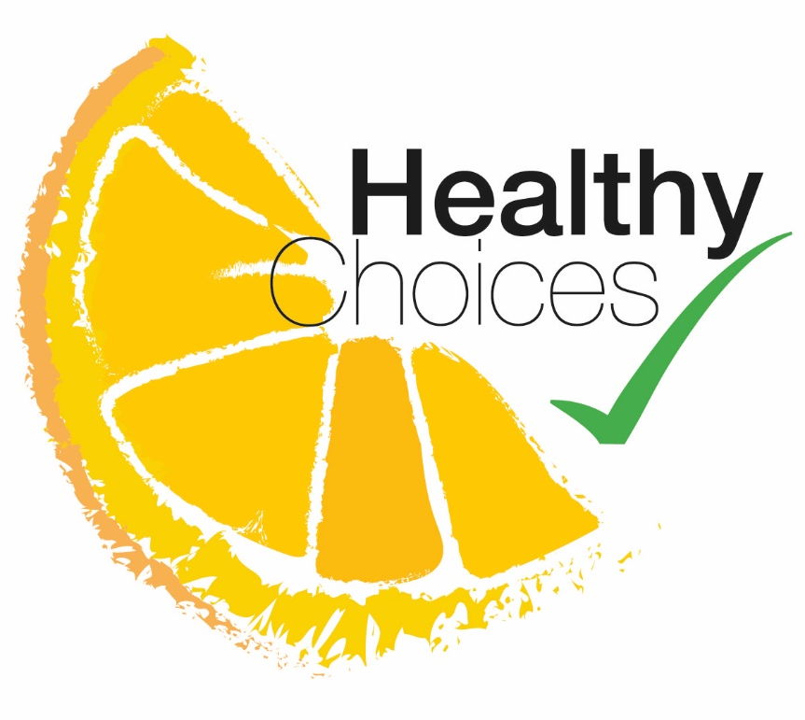

© Council of the Isles of Scilly

Please complete this form and return to us at: Environmental Health.
Also include a copy or photographs of your Menu
Council of the Isles of Scilly, Town Hall, St Mary’s, Isles of Scilly, TR21 0LW.
Contact us on 01720 424432 or at environmentalhealth@scilly.gov.uk

Please see the terms and conditions page at the end of this form
Name of establishment:
Address:
Name of contact person:
Telephone number: Email:

Type of establishment e.g. Café, restaurant, etc:

Independent business or group?

Average number of meals served daily/weekly:

Opening season/ days and hours:

How did you find out about our scheme?

Please detail below how you meet each of the criteria of the scheme
We will also require a copy of your Menu to be assessed by our consultant Nutritionist
- Healthier food and drink

Do you offer at least three healthier meal choices on your menu?
Reduced fats & salts/ lean meat/ baked potato alternative accompaniments etc.
Answer the rest of the form first if you are uncertain

Do you offer healthier choices of drinks?
(Reduced sugars/ calorie/ reduced alcohol etc.)

- Fresh fruits and vegetables
Do you sell fresh fruit, promote and include as snacks or in meals?

Do you include salad and vegetables as options within your meals? (including sides)

- Reduced Fats and salts

Do you use lower fat cooking methods wherever possible? Please detail:

Do you allow customers to add their own spreads/salad dressings etc.?

How do you minimise the use of salt in your cooking wherever possible?

- Food for all tastes and allergy awareness

Detail how provide accurate information to customers on which allergens are in the food you serve. Be mindful of the ingredients within other products that you add to food.

Do you offer smaller portion sizes?
This could advertised as “Children and less hungry adults menu”

Do you offer healthier main meals for children?

- Hate Waste

Do you have a flexible menu that allows you to use up food?

- Promotion and Customer Commitment

Do you and your staff promote your healthier choices?

Do you listen to your customers and make changes from their feedback

Local food How you meet the criteria

Do you use local food or produce in your menu?

Any other information that you would like to add or help and guidance that you would like on a particular issue?

Please read the terms and conditions (next page) and if in agreement, sign and date below:

Name Signature

Date

Office use only
Lead Officer |  | Date-
Application received complete? |  | Date-
Passed to Nutritionist |  | Date-
Additional requirements required by food FBO.  Nutritionist comments |  | Date-
Accreditation passed |  | Date-
Verified by |  | Date-

Terms and Conditions of membership of the scheme

The One off membership fee is £50. Payment is by BACS or cheque. Cheques should be made out to the Council of the Isles of Scilly and can be attached to this form. BACS payment details can be provided on request to environmentalhealth@scilly.gov.uk A receipt will be issued.

You can only apply to be part of the Healthier Choices scheme if your business has achieved and maintains level 4 or 5 of the Food Hygiene Rating Scheme.

The Council would like to promote your inclusion of the scheme using local media and our web site if you are successful in accreditation. You will remain a member of the scheme until at least Dec 31st 2020 when the project will receive a continuation review. If continued, you will remain a member without any additional fee in perpetuity until the Council no longer delivers the scheme.

Your business will be subject to a review at the next scheduled food safety inspection. This is to ensure that each business is still meeting all the criteria of the scheme so it is fair for all members and a review to make sure you getting the most out of your membership and the benefits it brings.

You will be sent a Certificate and a sticker with the Healthy Choices logo to display once IoS Environmental Health has received payment and accredited your membership of the award scheme.
The Accreditation Certificate and Sticker remain the property of the Council (as does your Food Hygiene Rating Score Sticker) and can be removed if you are no longer eligible for the scheme as below. If one or more of the following occurs, your premises will no longer be part of the scheme. Fees will not be reimbursed.

- If following an inspection or complaint, your business is no longer a level 4 or 5 under the Food Hygiene Rating Scheme
- If your business is no longer meeting the criteria
- If the ownership of the business changes

In the above situations, the certificate, sticker and logo or any reference to the scheme will no longer be applicable and must not be used. The EHO may remove the sticker from display and retain.

The assessment is based on the information provided by you on the self-assessment questionnaire and what is seen by the assessor during their visit. A consultant nutritionist will check the information provided also. The Senior Environmental health Officers decision on accreditation is final. If during the initial assessment visit your business is not meeting all the criteria, you are entitled to up to one hour of support and guidance, followed by a re-assessment without additional fees. Any additional hours support required may be charged in agreement at our hourly rate.

The logo, window sticker and certificate must only be used by your business and no other businesses and will remain the property of Council of the Isles of Scilly

You should display the certificate in a prominent place within your business and proudly promote the fact that you offer healthier options. By becoming a member of the scheme you agree to us contacting you by telephone, email, post and using your information within the terms of our GDPR statement.

