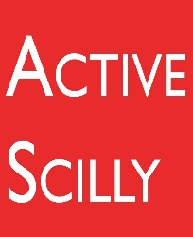
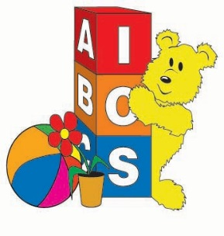
Council of the Isles of Scilly
Summer 2017 Children’s Holiday Activities
Booking Form
Please complete this booking and consent form and return to the Sports Hall reception prior to the day of the activity(ies). We require one consent form per child, but only one consent form for all the activities is required.
Child’s Name ………………………………………………………………………………
Activity | Date | Cost
Total Sum Owed

Total amount paid (if for more than one child) …………….by cash / cheque / card (please circle) Please make cheques payable to the Council of the Isles of Scilly.
Payment by card can be taken at the Sports Hall desk or by telephone – contact 01720 424373.
One Stop Shop Opening Hours
For Bookings contact the Sports Hall on 01720 424373 or enquiries contact Children’s Services on 01720 424303.
Monday – Friday 12.00 – 19.30
Saturday 10.00 – 13.00 Sunday 10.00-13.00
Consent Form
Name of Child: ………………………………………………………………..
Child’s Age: ................
Child’s Date of Birth: ………………………………….
Parent/Carer/Guardian
Name(s) :.................................................................................

Address:...........................................................................................................................................................................................................................................................................................................................................
Telephone (both land line & mobile if applicable)
....................................................................................................................
……………………………………………………………………………………

E-mail address (if you would like to be added to our mailing list)
……………………………………………………………………………….

Contact Details – friends & family
Please give us 2 contact details of who we should contact should the need arise while your child is in our care. One of these can be the same as above.

Contact 1 :............................................. Telephone:.................................
Relationship to child ………………………………………………
.
Contact 2:............................................... Telephone:.................................
Relationship to child …………………………………………….

At the end of sessions my child will:
Be collected ⃝ Walk home ⃝ Other:....................................

Does your child have 1:1 support during the school day? (This may need to be considered when children are accessing activities.) Yes / NO
(If yes, please provide a little more information below.
………………………………………………………………………………………………………………………….
………………………………………………………………………………………………………………………….
For children booking onto the Swim Session, please indicate the level of your child’s swimming ability by circling one of the below statements;

Non swimmer Can swim up to 25M Can swim 50m
competent swimmer

You must give consent if you wish qualified staff to administer first aid in circumstances where unexpected attention is required or prescribed medication. You will be informed as soon as possible. A qualified first aider will be on site during all activities. All activities are subject to a full risk assessment prior to each activity.
I do give consent I do not give consent
We will be taking photographs during the activities. Your child’s image may be used for marketing and display purposes. Formats may include your child’s image being displayed on the Children’s Services Facebook page, display boards or in local publications. All images will be used appropriately and responsibly.
I do give consent I do not give consent

Signed………………………………………………………………………………………………………………
Relationship to child………………………………………………………………………………………..
Is there anything we should know about your child to help them get the most from these activities? (Please use additional sheets to provide information if necessary.)
………………………………………………………………………………………………………………………………………………………………………………………………………………………………………………………………………………………………………………………………………………………………………………………………………………………………………………………………………………………………………….

