UNIT 14b PORTHMELLON INDUSTRIAL ESTATE, St MARY’S, ISLES OF SCILLY

DESIGN & ACCESS STATEMENT

AUGUST 2017

Refurbishment of existing Unit 14b. Construction of a brand new warehouse unit on the adjacent land.

INTRODUCTION
The current land and premises are situated on the Porthmellon Industrial Estate, on the edge of Hugh Town.
Porthmellon is the recognised industrial location on St Mary’s and comprises a small estate of mixed light industrial units, warehousing, retail outlets and craft workshops of varying age, design and construction. Nearby occupiers include workshops, building supplies merchant, a mobile catering outlet, bike hire business and craft centre.
From the site there is direct access to the industrial estate service road and also face Telegraph Road, one of the island’s main thoroughfares, although there is no direct access to telegraph Road.
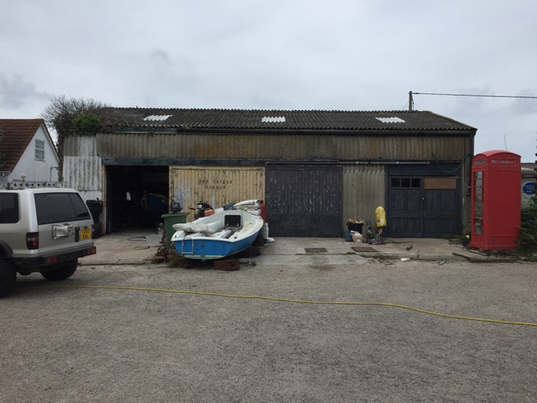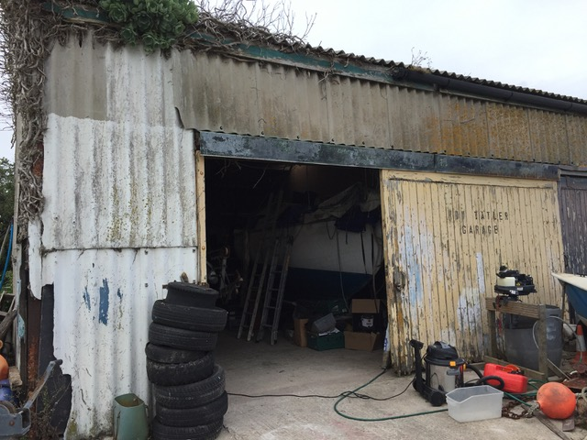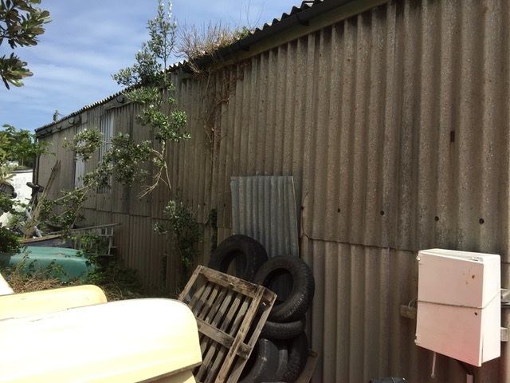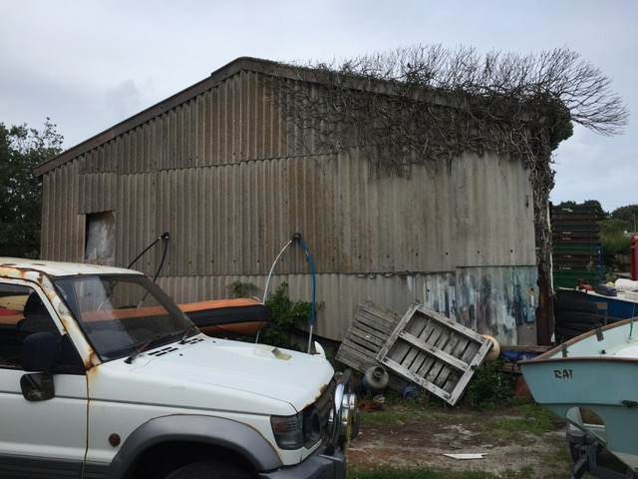

The subject premises comprise the left hand section of a detached industrial unit built in 1983/84. The property is built to a basic specification of steel portal-frame construction, having corrugated cement fibre sheet cladding to the walls. The roof is pitched, having timber purlins supporting a corrugated sheet roof covering. There are intermittent translucent light panels, several of which span the internal party wall, which is of timber stud construction with connecting door. There is no fire separation to the adjoining unit and no insulation in the roof or walls.
The premises have a sliding vehicular doorway on the front (south easterly) elevation, of timber construction, opening onto an area of hard-standing suitable for off-street car parking.
Internally a corner of the accommodation has been partitioned to create a small office.
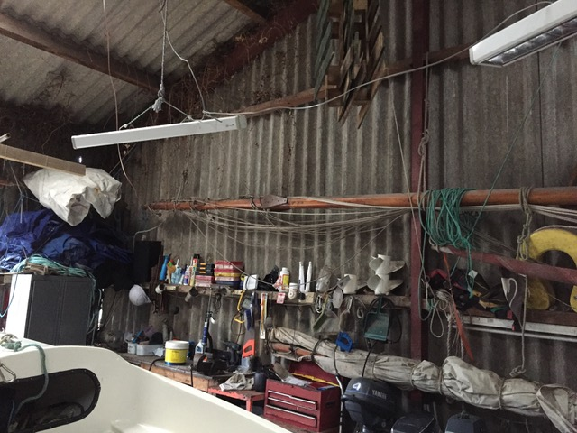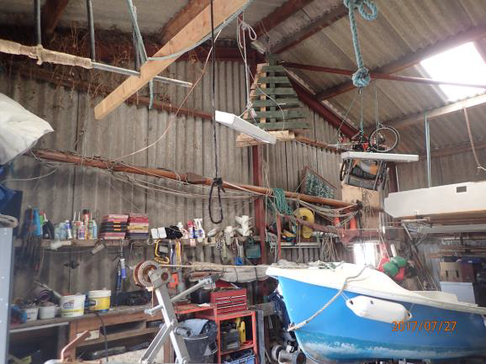
In addition to the hard-standing at the front, Unit 14B also has the benefit of a separate plot of rough storage land to the left of the premises, access to which is allowed across a small area of land we believe belongs to the Council of the Isles of Scilly and is used in common with the owner of Unit 14A, who occupies the remainder of the land to the side and rear of Unit 14B. UNIT 14b Porthmellon Industrial Estate
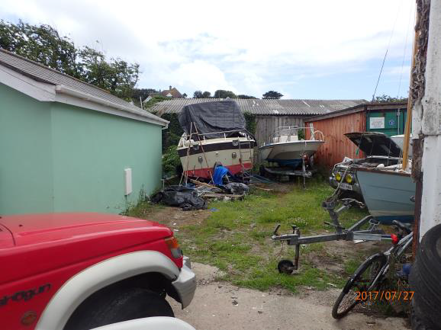

EXISTING USE
The premises are currently occupied by The Isles of Scilly Sailing & Windsurf Centre as a boat repair workshop and storage facility, albeit the building appears to be in a below-average state of repair. The timberwork would benefit from redecoration, and several of the corrugated sheet panels, which have been damaged, need replacing. Surrounding vegetation generally needs cutting back to prevent further ingress into the unit.
The adjacent land has 2 x small steel shipping container units on site, along with a mix of boats and associated equipment that is all in seemingly poor condition. All this is to be removed from site by the present owners prior to completion of the purchase.

PROPOSALS & OBJECTIVES
Carry out a thorough clearance of the overall site, removing the overgrown vegetation etc., to make for a more appealing approach/site.
Renovate existing Unit 14b, through re-cladding and re-roofing with modern day materials, to provide a suitably watertight building for the secure storage of electric vehicles.
Provide a brand new warehouse unit in modern day materials and to suitable specifications, to house a new Distillery for the production of Spirits, initially Gin, in accordance with the recently approved ERDF Voucher Scheme project for this new business.

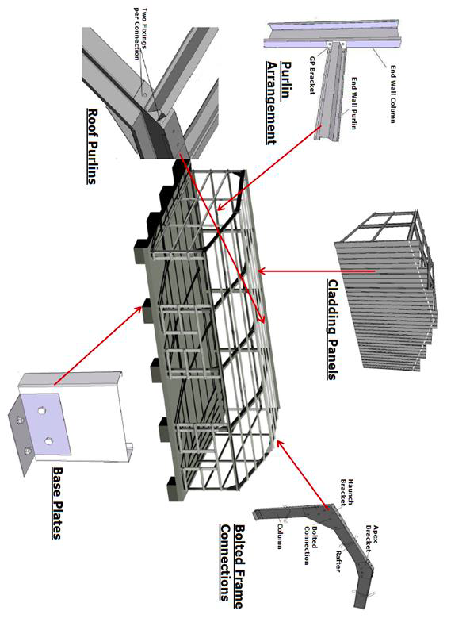
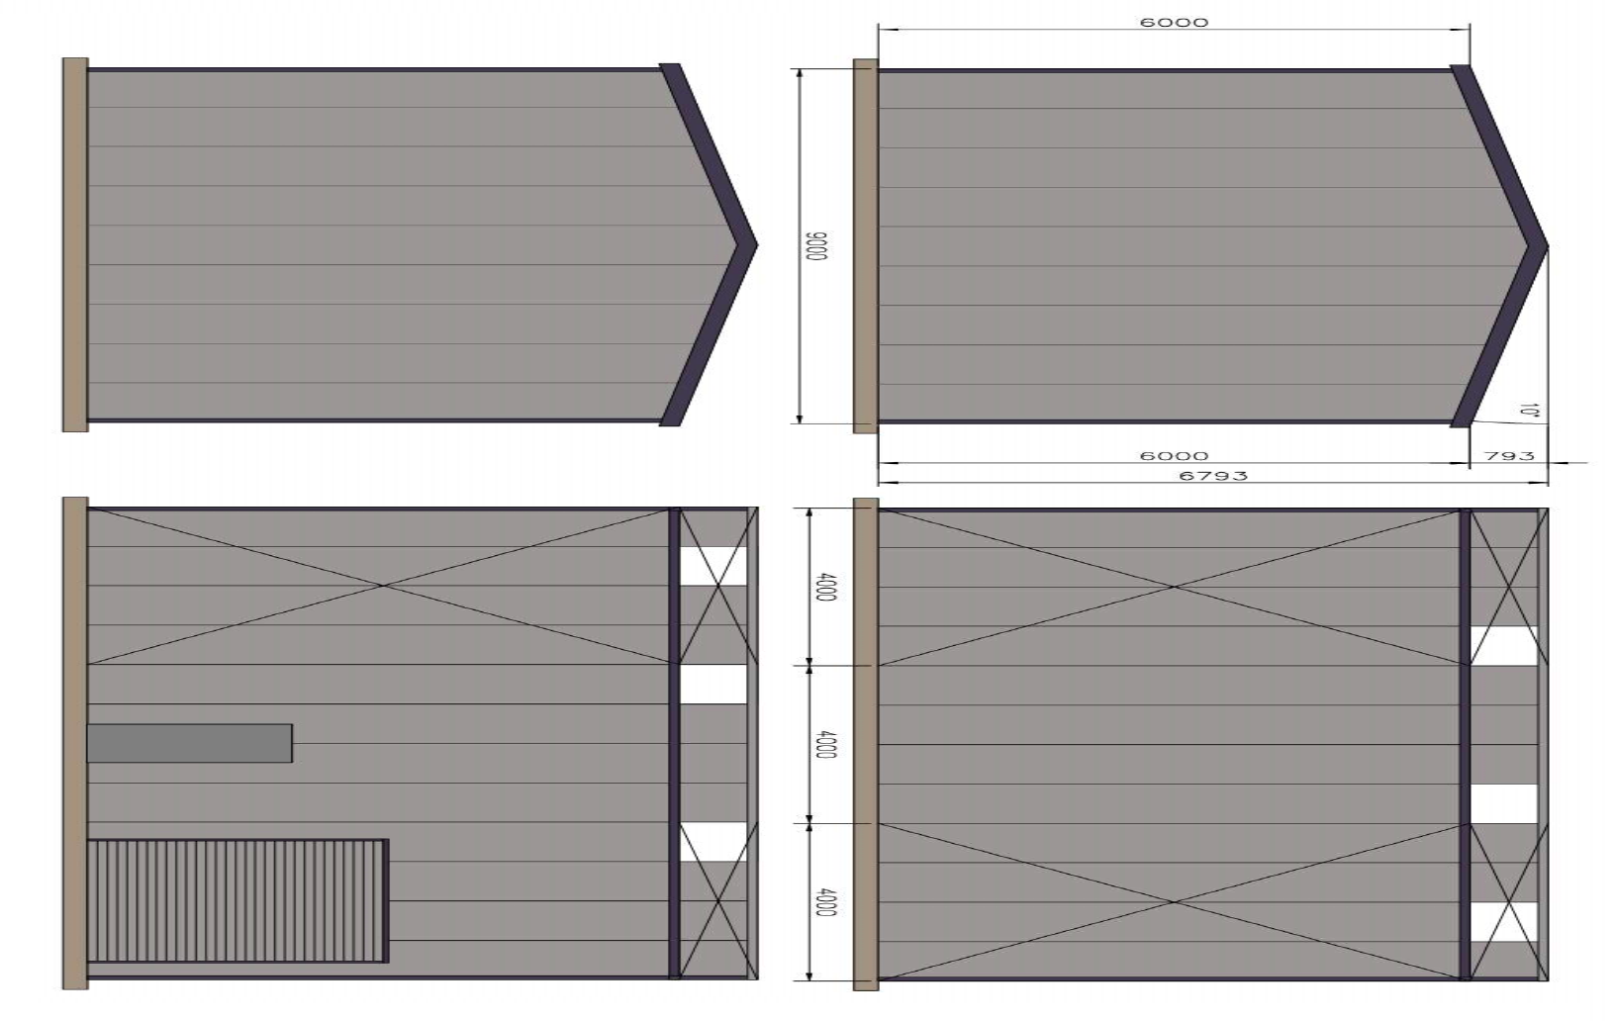

SUSTAINABILITY
The proposed works will a) Improve the longevity of the current building through use of modern day materials, made to current specifications, and b) Enhance the overall site/plot with the provision of a new unit in modern materials, in addition to clearance for the current poor state of the site overall.

IMPACT ON NEIGHBOURS
There will be no major impact on neighbouring units. There will be adequate/improved separation between Unit 14b and Unit 14a (owner of latter unwilling to take the opportunity to share full re-cladding/re-roofing to enable the overall building to be updated)

ACCESS
There will be no alterations to vehicular or pedestrian access to the site or either property.

