By e-mail

25th April 2022

Dear Sirs,

Council of the Isles of Scilly – 3 Ennor Close disability adaptations

Please find enclosed and attached the tender documentation inviting you to submit a bona fide quotation for this project.
Quotes are to be returned, not later than 16.00 on Friday 8th April 2022. All submissions are to be submitted in a pdf e-mail to procurement@scilly.gov.uk Quotations are expected to be held for 1 month from the deadline date. The Council reserves the right to conduct a search with a credit reference agency to determine the financial status of the preferred bidder.
The information required to be submitted with your tender submission are as follows:
- Completed and signed forms of tender
- Completed response to the request for quotation form
- Completed Schedule of Works document
Please acknowledge receipt of the above tender documentation and your willingness to tender within 2 working days.
We look forward to your response.
Yours sincerely,
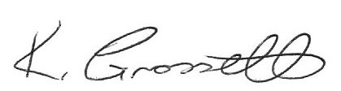
Senior officer: capital development and procurement
Council of the Isles of Scilly

