Council of the Isles of Scilly Inter Agency Referral Form
The Cornwall and Isles of Scilly Safeguarding Children Board has agreed that all contacts with Children’s Social Care should be made using the inter-agency referral form. The form is in line with the requirements of Working Together to Safeguard Children 2015 and local procedures for sharing information when you have concerns about the welfare or development of a child.
This form should be completed fully with the consent of the child/family. However, “this should only be done where such discussion and agreement seeking will not place a child at further risk of significant harm or prejudice enquiries under Section 47 of the Children Act 1989, or a police investigation”. This will help Children’s Social Care to deal with the case at the right level of intervention in accordance with the Threshold of Need.
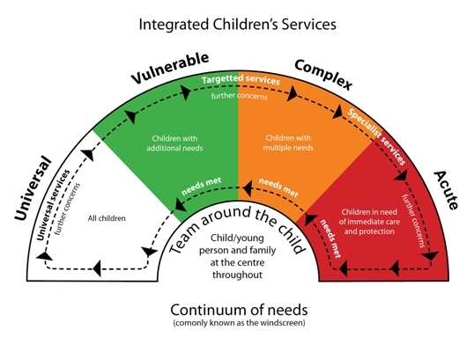
Levels of Vulnerability and Need
LEVEL 1  Universal Services | Children with no additional needs who make good overall progress in all areas of development and receive appropriate universal services.
LEVEL 2  Children with additional needs. | Children whose health and development may be adversely affected and who would benefit from extra help in order to make the best of their chances.
LEVEL 3  Children with multiple needs | Children whose health and/or development is being impaired or there is a high risk of significant impairment
LEVEL 4  Children in need of protection | Children who are experiencing significant harm or where there is a high likelihood of significant harm

If the professional view is that the family/child would benefit from a TAC/F then the Early Help Assessment should be completed rather than the inter agency referral form.
Council of the Isles of Scilly Inter Agency Referral Form
Child or young person’s details
Name
Telephone/Contact details

☐ Male | ☐ Female | DoB or EDD
Address

Post code

Child or young person’s details continued
Religion
First language
Do you understand written English? Please tick |  | ☐Yes ☐ No
Are you disabled? Please tick as appropriate |  | ☐Yes ☐ No
If yes, give details

Do you need an interpreter or signer? Please tick as appropriate |  | ☐Yes ☐ No
If yes, has this been arranged? Please tick as appropriate |  | ☐Yes ☐ No
Details of any special requirements

Who lives with you (the child)?
Name | Date of birth | Relationship to you
Other significant family members (e.g. friends, family, parents without parental responsibility)
Name | Date of birth | Relationship to you
Details of person/s with parental responsibility
Name |  | Name
Address |  | Address
Contact details |  | Contact details
Relationship to you |  | Relationship to you
First language |  | First language
Are any additional communication methods needed. ☐Yes ☐ No |  | Are any additional communication methods needed ☐ Yes ☐ No

People / Agencies involved with the family

Agency | Practitioner’s Name | Contact Details | Contributed towards assessment?
GP
School / Nursery
Health Visitor / School Nurse
Add other agency/ies involved with the child/family below:

GENOGRAM

Referrer details

Date of referral (THIS NEEDS TO BE COMPLETED)

Name of person undertaking referral

Role
Organisation
Address and Postcode

Contact details (Phone & Email)

Family Summary
Consider both the strengths and worries for the child. Be clear about what the current worries are and how the strengths support improvements for the child. Be clear about what you consider what could happen if the worries are not sorted out. Include Health, Development, Education, Parenting Capacity, Family and Environment factors.

What are we worried about?
What has happened or what have you seen that has made you worried about this child/YP

Ethnicities
☐ Mixed – Other Mixed Background  ☐ Mixed – White and Asian  ☐ Mixed – White and Black African  ☐ White Other European  ☐ Mixed – White and Black Caribbean. | ☐ White British  ☐ White Irish  ☐ White Other Cultural Background  ☐ Any Other Ethnic Group  ☐ Client declined
Family consent for information sharing and storage (where appropriate)
Do you agree to the information recorded on this form being shared with other practitioners and /or services in order to support you? Please tick as appropriate
☐Yes | ☐No | ☐Some
If no or some, what information can/cannot be shared and with whom?

I agree that the information on this form can be securely stored centrally by Children’s Social Care. |  |  | ☐Yes ☐ No

Parent/Carers’ Name:
Signature: |  | Date:
Child’s Name: |  | DOB

Give a copy to the child, young person or family, retain a copy for the practitioner and, if consent is given, send a copy to:
Children’s Social Care, Carn Gwaval, St Mary’s, Isles of Scilly, TR21 0NA
01720 424483
ChildrensSocialCare@scilly.gov.uk

This is for secure storage and to avoid duplication only. The Children’s Social Care Team will not use this Referral for any other purpose or share information without your consent.
If you do not consent to information being shared, this may impact on our ability to provide services to you and your children.

Data Protection Notice
The personal information that you give us will be processed by Council of the Isles of Scilly in accordance with the Data Protection Act 1998 and will only be used for the purpose(s) of providing services to you and your children. This information will only be shared within the Council and with other organisations to ensure the best possible outcomes for your family but may also be disclosed if required by over-riding legal statute or, to protect you or others from harm.

