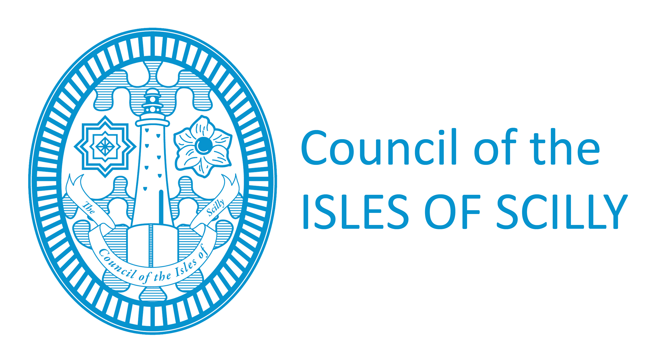
Licensing Department
Town Hall
St Mary’s
Isles of Scilly
TR21 OLW
Tel: 01720 424016/008
Fax: 01720 422202
licensing@scilly.gov.uk

Notification of Change Name or Alteration to Rules of Club

PLEASE READ THE FOLLOWING INSTRUCTIONS FIRST


If you are completing this form by hand please write legibly in block capitals. In all cases ensure that your answers are inside the boxes and written or typed in black ink. Use additional sheets if necessary. You are advised to keep a copy of the completed form for your records.

1. NAME OF CLUB
2. POSTAL ADDRESS OF CLUB
Post town |  |  | Post code

TELEPHONE NUMBERS
Daytime
Evening
Mobile
FAX NUMBER

EMAIL ADDRESS (if you would prefer us to correspond with you by email)

3. DETAILS OF CLUB PREMISES CERTIFICATE HELD
Certificate No.

4. NEW NAME OF CLUB (if applicable)
Club premises Certificate should accompany this notification or, if that is not practicable, a
statement of the reasons for failure to produce the Certificate.

Address for correspondence associated with this application (if different to the address above)

Post town | Post code

5. NOTIFICATION OF ALTERATION OF CLUB RULES (if applicable)
Please give relevant club rule numbers which have been altered

6. CHECKLIST:
Please tick if yes
I have enclosed my Club Premises Certificate (if change of club name effected)
I have enclosed a copy of the new club rules (if applicable)
I have enclosed payment of £10.50 – (make cheques payable to Council of the Isles of Scilly)

7. DECLARATION
I, …………………………………………………………………….. (insert full name) make this notification on behalf of the club and have authority to bind the club.
SIGNATURE |  | DATE

CAPACITY

If notification as required under S82 of the Licensing Act 2003 is not given within the 28 days following the day on which the change of name or alteration to the rules is made, the secretary of the club commits an offence which could result in prosecution and a fine not exceeding level 2 on the standard scale.
For official use only
Signed application form
Club Premises Certificate – If not, statement of reasons for failure to produce same
(If change of name effected)
Copy of Club Rules (if applicable)
Cheque for £10.50 made payable to Council of the Isles of Scilly

