Environmental Health Enforcement and Compliance Policy

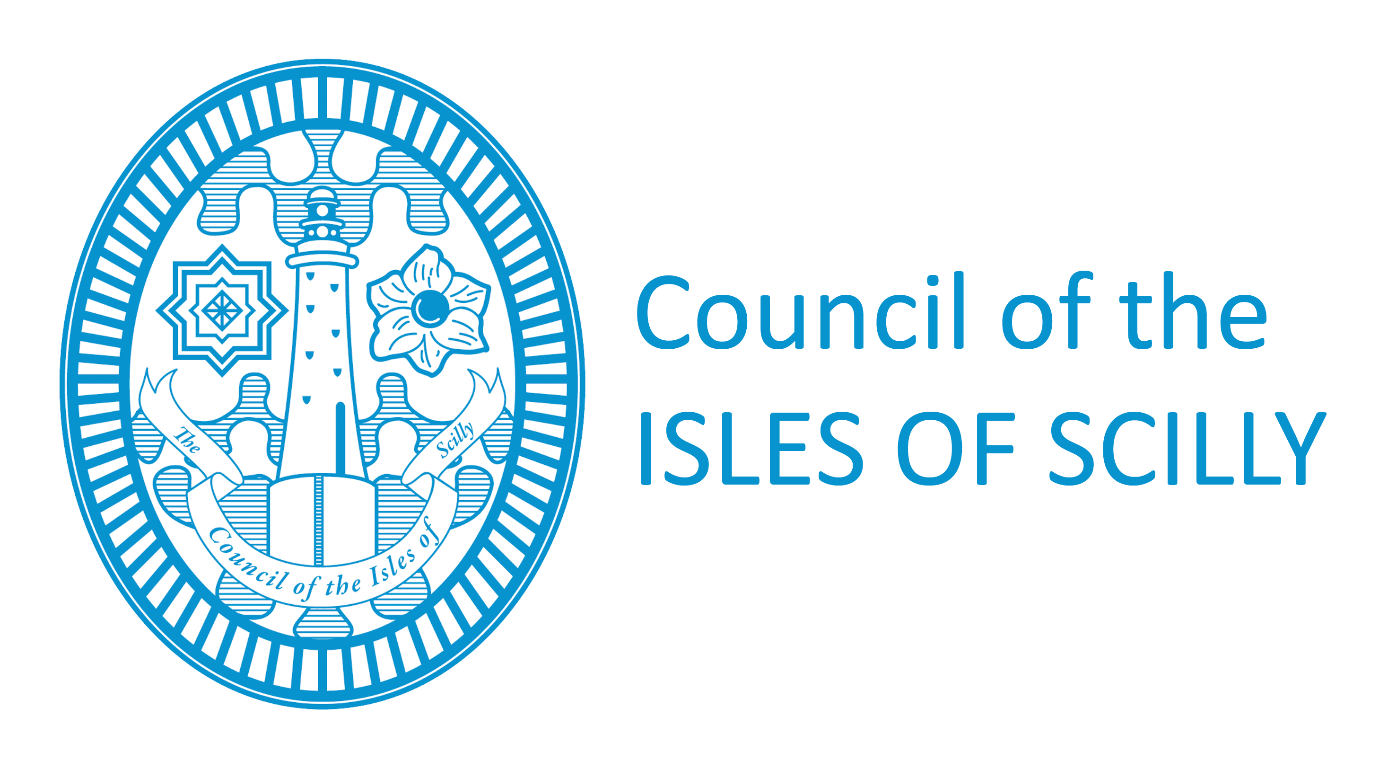
March 2018

Version |  | Approving Committee | Full Council
Date |  | Ratified by Council
Responsible Officer | Michael Coates | Review Date | 9/2/18

Version History
Date | Version | Author/Editor | Comments
21/04/2015 | 0.1 | David Currie | Initial Policy document
9/2/2018 | 0.2 | Michael Coates | Revision of policy
06/03/18 | 0.3 | Nicola Stinson | Contact details updated
12/3/18 | 0.4 | Michael Coates | Final amendments

Equalities Impact Assessment Record
Date | Type of Assessment Conducted | Stage/Level completed (where applicable) | Summary of Actions Taken  Decisions Made | Completed by. | Impact Assessment Review date

Document retention
Document retention period | 7 years

Contents

Environmental Health Enforcement Policy 4
Aim and Scope 4
Principles of Enforcement 4-5
Proportionality 5
Consistency 5
Transparency 5-6
Targeting 6
Accountability 6-7
Investigation 7
Confidentiality 7
Levels of Enforcement Action 7
Informal Action 7-8
Formal Action 8-9
Prosecution 9-10
Decision-Making process 10-11
Working with other Regulators 11
Recovery of Costs 11
Public Access to Information 11
Comments 12

Environmental Health Enforcement Policy
The Council of the Isles of Scilly has a duty to ensure compliance with Environmental Health legislation that regulates a wide range of activities. This document sets out why and how this is done.
The Council of the Isles of Scilly has delegated its compliance activities to officers and primarily the Senior Manager, Strategic Development. The range and complexity of the legislation is such that compliance activities will be undertaken by appropriately trained and experienced officers.
The Council recognises that the first step in enforcement is to prevent contraventions of the law by raising awareness and promoting good practice. Methods of achieving this include training courses, special events, production of guidance leaflets, issue of press releases and opportunities presented by contact with businesses and other customers.

Aim and Scope
Through the application of its Environmental Health functions the Council aims to protect the public, the environment, businesses, consumers and workers. It is committed to these objectives in its approach to enforcement action which is intended to;
- Ensure that compliance is met in a fair, equitable and consistent manner.
- Focus on prevention rather than cure.
- Assist businesses and others in meeting their legal obligations without unnecessary expense.
- Take firm action against those who flout the law or act irresponsibly.
The policy sets out the principles and approach that will be followed so as to provide an effective and fair service and to ensure consistent and open enforcement. It applies to all dealings in Environmental Health matters, whether formal or informal, with businesses or members of the public. The policy does not apply to offences where fixed penalty schemes are in place. This policy is written for the guidance of the Council and its officers and is available to anyone who enquires about our policies and procedures.
In addition to this generic policy, officers have been issued with a range of more specific enforcement guidelines and procedural documentation to support them in their enforcement decisions. This policy also encompasses the aims and principles of the government’s Concordat on Good Enforcement.

Principles of Enforcement
The Council believes in firm but fair regulation. This should be informed by the principles of proportionality in application of the law and in securing compliance, targeting of enforcement action, consistency of approach, transparency about how the Council operates and what those regulated may expect from the Council and accountability for the Council’s actions.
Where possible the Council will advise, educate, train and support businesses to meet the standards required to prevent the need for enforcement action.

Proportionality
The Council will minimise the costs of compliance by ensuring that any action it requires is proportionate to the risks. As far as law allows, the Council will take account of the circumstances of the case and the attitude of the offender (operator or member of the public) when considering action.
Some incidents or breaches of regulatory requirements cause or may have the potential to cause serious injury/illness and/or environmental damage. Others may have a lesser effect e.g. interference with people’s property or rights. When officers are deciding on the most appropriate enforcement action, they will take account of;
- The degree of any risks posed.
- The seriousness of any breach of the law.
- The burden which would be placed on the business in taking action, compared with the benefit of risk reduction.
- The attitude and intent of the offender.
- Foreseeability of the offence or circumstances leading to it.
- Relevant good practices as obtained in the codes of practice and published guidance.

Consistency
The Council aims to ensure consistency in advice tendered, the response to incidents and complaints, the use of all powers and decisions on whether to prosecute.
The Council recognises that consistency does not mean simple uniformity. Officers need to take into account many variables, the scale of the environmental impact etc., the attitude and actions of the offenders and the history of previous incidents or breaches. Decisions on enforcement action are a matter of professional judgment and the Council, through its officers, needs to exercise discretion. The Council will continue to develop arrangements to promote consistency including effective arrangements for liaison with other enforcing authorities.

Transparency
Transparency is important in maintaining public confidence in the Council’s ability to regulate. It is an integral part of the role of Council Officers and the Council continues to train its staff and to develop its procedures to ensure that;
- Where remedial action is required, it is clearly explained in writing why the action is necessary and when it must be carried out; a distinction being made between legal requirements and advice on best practice.
- Opportunity is provided to discuss what is required to comply with the law before formal enforcement action is taken, unless urgent action is required, for example to prevent serious illness/injury or to prevent evidence being destroyed.
- Where urgent action is required, a written explanation of the reasons is provided as soon as practicable after the event.
- Written explanation is given of all rights of appeal against formal enforcement action at the time the action is taken.
- Having due regard to legal constraints and requirements, keep relevant parties informed during investigations and with respect to enforcement decisions.

Targeting
Action will primarily be focused on law-breakers and/or those directly responsible for the risk and who are best placed to control it. The Council will have systems for deciding which inspections, investigations or other regulatory contacts should take priority according to the nature and extent of the risks posed.

Accountability
The Council and its officers fully recognise that they are publicly accountable for their actions. Consequently policies and standards have been put in place against which the Council’s actions can be judged and procedures exist for dealing with feedback and handling complaints. In addition the Council will comply with legislation that protects the rights of persons subject to legal action, which controls how evidence against offenders may be obtained and which preserves the confidentiality of personal information. Particular consideration will be given to The Human Rights Act 1998, The Data Protection Act 1998, the Regulation of Investigatory Powers Act 2000 and the Crime and Disorder Act 1998.
In the event that the customer is dissatisfied with the Service provided, there are a number of forms of recourse available as outlined below, which officers will ensure the customer is aware of. The exact procedure followed in any particular case will depend not only on the nature of the grievance itself but also the course of action the complainant wishes to pursue.
- Complaints related to the enforcement action decisions
Officers will when serving notices provide with those notices appeal details to be used and should the recipient wish to disagree they can follow the appeals process for the said notice.

- Complaints relating to issues other than enforcement decisions
The Council’s formal complaints procedure will be used to investigate those complaints which relate to dissatisfaction with the service, for example;
- Failure to follow Council procedure, policy or standards.
- Alleged discrimination.
- Failure to respond to requests for service.
- Conduct of Authorised officers.
- A copy of the Council’s feedback policy can be found at www.scilly.gov.uk/complaints.

Investigation
The Council recognises that it is neither possible nor necessary to investigate all issues of non-compliance with the law uncovered in the course of preventive inspection, or in the investigation of reported events such as accidents and complaints. The Council will use its discretion and have regard to the aforementioned principles in deciding whether an investigation should be initiated and in deciding the level of resources to be committed. The following factors will be taken into account;
- The severity and scale of the potential or actual harm.
- The seriousness of any potential or actual breach of the law.
- The enforcement priorities.
- The practicality of achieving results.

Confidentiality
The Council understands that people making complaints may not wish their identity to be made known to the party about whom the complaint is being made and wherever possible we will take care to protect the confidentiality of complainants. However in some circumstances, papers relating to individual cases may be in the public domain. If this is the case we will endeavour to make it clear whether or not complainant confidentiality can be maintained. Anonymous complaints will only be investigated if it would be in the public interest and directed to their local member who can make representation on their behalf.

Levels of Enforcement Action
The Council recognises that the first step in enforcement is to prevent contraventions of the law by raising awareness and promoting good practice. Methods of achieving this include training courses, special events, production of guidance leaflets, issue of press releases and opportunities presented by contact with businesses and other customers.
In the event that breaches of legislation are discovered officers will determine what, if any, enforcement action is appropriate, in accordance with the aforementioned principles. The following informal and formal options are available;

Informal Action
The Council recognises informal action as one means to secure compliance with the law. Informal action includes;
- Verbal advice/warning.
- Advisory letter where advice is being confirmed or remedial action requested informally.
- Inspection reports generated on the premises following an inspection.
Informal action is appropriate in the following circumstances;
- Where the action or omission is not serious enough to warrant formal action.
- From the individual/enterprise’s management, it can reasonably be expected that informal action will achieve compliance.
- Confidence in the individual/enterprise’s management involved is high.
- The consequences of non-compliance will not pose a significant risk to public health.

Formal Action
In cases where informal action has failed to achieve the necessary outcome or the breach is serious enough to warrant formal action in its own right, the following enforcement options will be considered;
- Enforcement Notice.
For example Improvement Notice, Prohibition Notice or Abatement Notice. In certain cases these may be needed to be served prior to legal proceedings being instigated. The Council will give due consideration to the issue of enforcement notices as soon as the necessary evidence is available and where one or more of the following criteria apply;
    - The specific legislation requires that a notice shall be served when circumstances leading to the existence of a statutory nuisance have been proved.
    - There are significant contraventions of legislation.
    - There is a lack of confidence in the proprietor or enterprise to respond to an informal approach.
    - There is a history of non-compliance with informal action.
    - Standards are generally poor with little management awareness of statutory requirements.
- Fixed Penalty Notice.
Where this enforcement option is available under legislation, a Fixed Penalty Notice will be issued in line with the principles of proportionality, targeting and consistency. The Council will seek to avoid wherever possible issuing fixed penalty notices to anyone under the age of 18. The Council will work to prevent offending by young people by undertaking the following;
- Letters to parents and guardians.
- Schools based education.
- Interaction with local youth clubs and community groups.

- Licenses or Authorisations.
Where relevant powers exist and the circumstances warrant it, these may be varied suspended or revoked if conditions are not complied with or in order to protect the public from regulated activities carried out to a poor standard.
- Caution.
Where a business admits to an offence and extenuating circumstances exist which may make prosecution inappropriate. A caution is a proportionate response where an offender formally acknowledges that they have committed an offence and may only be used where a prosecution could properly have been bought. It will be brought to the Court’s attention if the offender is convicted of a subsequent offence.
The Council will take account of current Home Office guidelines when considering whether to offer a caution. Where a person declines such an offer the Council will consider taking alternative enforcement action, which will usually take the form of a prosecution.
The Council recognises that other bodies such as home and originating authorities will require to be advised of cautions issued by the Council and their outcome.
- Works in default.
This action is permitted under certain legislation and is reserved for those cases where there is imminent danger to persons or property and the legal process would not provide adequate remedy. In cases where work in default is carried out, the Council will make every effort to recover the costs of the works from the relevant party.
- Seizure and Rendering Harmless.
Certain legislation allows for the seizure of food, articles or substances if they could cause harm if consumed or pose a risk of serious personal injury, or if in breach of a specific prohibition for example under street trading legislation. Procedural guidance is available to officers which should be followed in these circumstances.
- Arrangements where the Council is the proprietor of a business.
Where the Council is the proprietor of a business, details of non-compliance shall be brought to the attention of the Senior Manager. In the event where the non-compliance is deemed to warrant formal action, the matter will in addition be drawn to the attention of the Corporate Leadership Team.

Prosecution
The use of the criminal process to institute a prosecution is an important part of enforcement. It aims to punish wrongdoing to avoid a recurrence and to act as a deterrent to others. It follows that it may be appropriate to use prosecution to ensure certain requirements are met. Where the circumstances warrant it, prosecution without prior warning or recourse to alternative sanctions will be pursued.
The Council recognises that the institution of a prosecution is a serious matter that should only be taken after full consideration of the implications and consequences. Decisions about prosecution will take account of the Code for Crown Prosecutors issued by the Crown Prosecution Service.
A prosecution will not be commenced or continued on behalf of the Council unless it is satisfied that there is sufficient, admissible and reliable evidence that the offence has been committed and that there is a realistic prospect of conviction. If the case does not pass the evidential test, it will not go ahead, no matter how important or serious it might be. When there is sufficient evidence a prosecution will not be commenced or continued on behalf of the Council unless it is in the public interest to do so.
Public interest factors which can affect the decision to prosecute usually depend on the seriousness of the offence or the circumstances of the offender and whether, through the conviction of offenders, others may be deterred from similar failures to comply with the law.
Where there is sufficient evidence the Council will normally prosecute in any of the following circumstances;
- Where the offence involves a failure to comply in full or in part with the requirement of a statutory notice.
- Where there is a history of similar offences in relation to non-compliance with notices.
- Excessive or persistent breaches of regulatory requirements.
- Obstruction of Council Staff in carrying out their powers.
- Where the gravity of the alleged offence, taken together with the seriousness of any actual or potential harm, or the general record and approach of the offender warrants it.
- Failure to supply information without reasonable excuse or knowingly supplying false or misleading information
- Impersonating a Council officer.

Decision-Making process
In cases of health and safety legislation it is the authorised officer(s) who have the power to take legal action. In other matters, the decision to prosecute rests with the officer having delegated authority. The requirements of the Scheme of Delegation will be complied with.
In all cases prior to making a decision to prosecute a full report will be prepared giving consideration to whether there is a reasonable prospect of conviction. Where there is a reasonable prospect of conviction the following matters will then be considered;

- the seriousness of the offence.
- the previous history of the party concerned.
- the likelihood of the defendant being able to establish a viable defence under the relevant statute if applicable.
- the ability of any important witness and their willingness to co-operate.
- the willingness of the party to prevent recurrence.
- the public interest of a prosecution.
- any explanation offered by the company/offender.
- whether other action such as issuing a formal caution would be more appropriate.
Where legal advice is necessary before a decision is made expert legal advice will be sought.
Where there is reasonable doubt as to the success of the proceedings and the possibility of costs being awarded against the Council, this will be included in the considerations made before a decision to proceed is taken.
In legal proceedings the Council will fully support the necessary action taken in all cases by the authorised officer.

Working with other Regulators
Where the Council and other enforcement bodies have the power to prosecute, the Council will liaise with that other body to ensure effective co-ordination, to avoid inconsistencies and to ensure that any proceedings instituted are for the most appropriate offence. The Council will also consult with other authorities acting as appropriate.
The Council will, when appropriate and when requested to, seek to raise the awareness of the courts of the gravity of certain offences and the full extent of their sentencing powers. In certain cases it may also be appropriate to draw to the attention of the courts and/or the Crown Prosecution Service to the fact that disqualification of a director may arise under relevant legislation.

Recovery of Costs
In carrying out the formal action outlined in this policy, the Council of the Isles of Scilly will endeavor to recover all reasonable costs incurred.

Public Access to Information
This policy will be made freely available to all members of the public on request and a copy will be posted on the Council’s website.
Officers will adhere to the restrictions placed on them by legislation in relation to the release of any information to a third party, obtained by them in the course of their duties. When convictions have been obtained however, the Council will, in addition to reporting the details to the relevant authorities, consider alerting the media and making the details of the conviction public. Such action will serve to draw the attention of a wider audience to the need to comply with legal requirements and deter others tempted to disregard their legal duties.

Comments
The Council welcomes comments on this policy and on how we can improve our services. Comments can be made in the following ways;

Email: environmentalhealth@scilly.gov.uk

By telephone on: 0300 1234 105

In writing to;
Environmental Health,
Council of the Isles of Scilly,
Town Hall,
St Mary’s,
Isles of Scilly,
TR21 0LW

