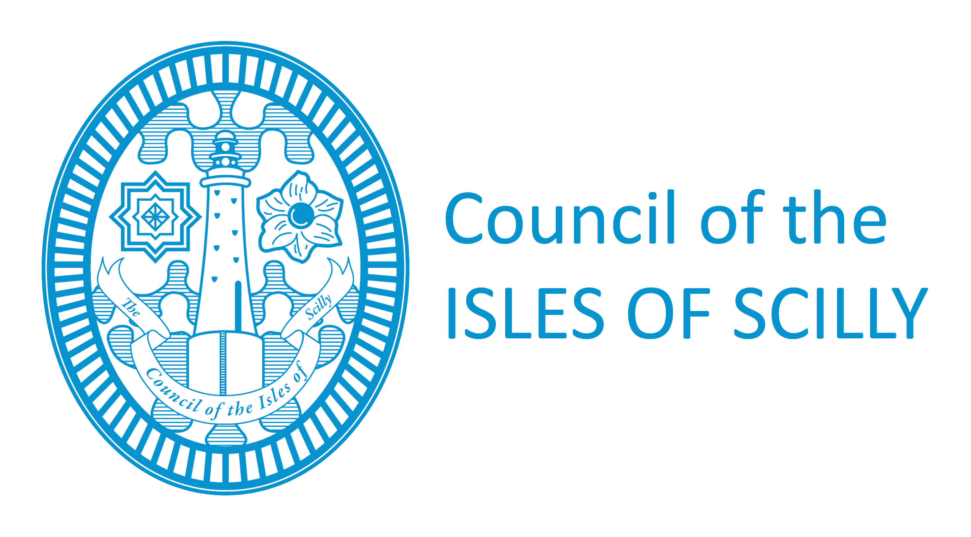
Licensing Department
Town Hall
St Mary’s
Isles of Scilly
TR21 OLW
Tel: 01720 424546
licensing@scilly.gov.uk

Application for copy of Premises licence/Temporary Event Notice

PLEASE READ THE FOLLOWING INSTRUCTIONS FIRST
This form can be submitted online to licnsing@scilly.gov.uk
If you are completing this form by hand please write legibly in block capitals. In all cases ensure that your answers are inside the boxes and written or typed in black ink.

1. YOUR PERSONAL DETAILS

Title (delete as appropriate): Mr Mrs Miss Ms Other (please state)

Surname:

Forenames:

Details of Licence required:
Licence No.
Premises

Detail of TEN Required : Premises

Date of TEN

2. ADDRESS WHERE ORDINARILY RESIDENT / email address: ( preferred)

(We will use this address to correspond with you unless you complete the separate correspondence box below).

Post Town |  |  |  | Post Code

Telephone Numbers
Daytime |  |  |  |  | Mobile
Email

3. Address for correspondence associated with this application (if different to the address above)

Post Town |  | Post code
4. PLEASE COMPLETE if Known:

Premises License No: | Issuing Local Authority:
6. CHECKLIST/ DECLARATION
Please tick yes
I have enclosed payment of £10.50 – (make cheques payable to Council of the Isles of Scilly) Payment can also be made by calling 03001234105 (Quote licence copy)

Signature:

