PUBLIC SPACES PROTECTION ORDER (PSPO) 2020-2023
RESIDENTS / BUSINESSES / VISITORS SURVEY
In 2016, as part of a consultation process, the CIOS conducted a comprehensive public survey for residents, businesses and visitors, with the aim of collating valued opinion and input for the purpose of a introducing a PSPO. This resulted in a PSPO which was set in place under the Anti-Social Behaviour, Crime and Policing Act 2014 for a period of 3 years. This survey seeks to validate the effectiveness of the current order not only as a deterrent to irresponsible dog control and dog fouling, but also as a clear guide for dog owners both resident and visiting. The response to this survey will form part of the consultation in determining the necessity and the content for the revised PSPO 2020-2023. The views of our residents, businesses and visitors are important to the council and we request that you please take a moment to complete this short survey by either of the following methods;
Online on the CIOS website; https://www.mysurveylab.com/pageTag/SurveyCampaign/cId/e6ced617b235d104e37c7b38226ef0c3a928cdedb/
Paper surveys can be found at Town Hall Reception, The Library and the Wellbeing Centre, St Marys to be returned to the Town Hall Reception whereupon an enclosed, confidential return box is situated.
By Post; Please return to;
Environmental Health, Council of the Isles of Scilly, Town Hall, St Mary’s, Isles of Scilly, TR21 0LW
The survey will run for 4 weeks from Monday 27th January and will conclude at 4:30pm on Friday 21st February 2020.
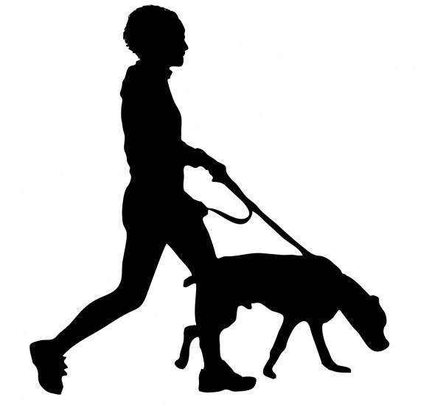
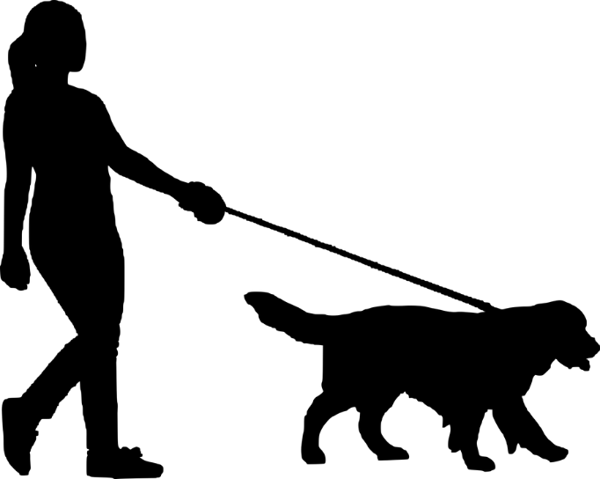
If you require further information please contact environmentalhealth@scilly.gov.uk
PSPO SURVEY 2020
Please circle the appropriate response
1. | Please state your residential status | Full Time Resident |  | Seasonal Resident |  | Visitor
2. | What is your age category? | Under 18 |  | 18-24 |  | 25-34
 |  | 25-34 |  | 45-54 |  | 55-64
 |  | Over 64
3. | Gender | Male | Female |  | Other |  | Prefer not to answer.
4. | Are you a dog owner? | Yes |  |  | No

The following statements reflect the current proposals for the 2020-2023 PSPO for the Isles of Scilly. Please indicate if you agree/disagree.
There is space for further comment at the end of the survey.
5. | The CIOS will continue to make it an offence for a person in charge of a dog to fail to remove and suitably dispose of dog faeces (exceptions apply). Enforced across the Isles of Scilly with the exception of Tresco. | YES | NO | Undecided
6. | The CIOS will continue the seasonal exclusion of dogs from the following beaches (1st May – 30th September);  - Porthcressa Beach, Hugh Town  - Porthmellon Beach, Hugh Town  - Old Town Beach, Old Town | YES | NO | Undecided
7. | The CIOS will continue to exclude dogs, at all times, from the following areas;  - Parade Park , Hugh Town  - Five Islands Academy Multi-Use Games Area (MUGA)  - Five Islands Academy Playing Field  - Skatepark, Old Town  - Garrison Playing Field  - Enclosed Children’s Play Area, The Garrison  - Porthcressa Enclosed Children’s Play Area, Hugh Town  - Enclosed Multi-Use Games Area (MUGA) pitch, St Agnes  - St Agnes Primary School Green  - Enclosed Multi-Use Games Area (MUGA) pitch, Bryher  - Community Centre and Children’s Play Area, Bryher  - Enclosed Tennis Courts , St Martins | YES | NO | Undecided
8. | The CIOS will continue to enforce the requirement for dogs to be kept on leads at all times in the following areas;  - The Bank, Hugh Town  - Hugh Street, Hugh Town  - Lower Strand, Hugh Town  - The Strand, Hugh Town  - Church Street (incl. Wellcross), Hugh Town  - Silver Street, Hugh Town  - Church grounds, St Mary the Virgin , Hugh Town  - Church grounds, St Mary’s Old Church, Old Town  - Church grounds, St Agnes Church, St Agnes  - Church grounds, All Saints Church, Bryher  - Church grounds, St Martin’s Church, St Martins | YES | NO | Undecided
9. | The CIOS will continue to enforce the requirement for dogs to be kept on leads in the following designated bird breeding grounds, during the breeding season (1st April – 30th September);  - Northerly point of White Island (North of St. Martin’s)  - Northern part of St Helens  - Headland behind the main farm building on Tean  - Northwest point of Northwethel  - Northerly point of Bryher  - Western Slope of North Hill (Samson)  - Southern coast of Samson  - Designated areas to the Northwest, Northeast and South coast of Gugh  - Eastern Isles; Little Gannick, Menawethan and Innisvouls and the southern ends of Great Arthur and Great Ganilly | YES | NO | Undecided
10. | The CIOS will continue to make it an offence for a dog owner to fail to put and keep a dog on a lead, when directed to do so by an authorised officer. | YES | NO | Undecided
11. | The CIOS should consider the introduction of a new offence which will apply to any responsible person in charge of a dog in a public space, who fail to produce a dog waste bag when challenged by an authorised officer( comments are particularly welcome on this proposal). | YES | NO | Undecided

This section offers opportunity for you to offer additional comments.

Thank you for your valued time.

DATA PROTECTION
The Data Controller for the information you provide on this survey, is Cornwall Council, New County Hall, Treyew Road, Truro TR1 3AY. Data Protection Registration Number: Z1745294.
This survey is conducted by the Environmental Health Service, council of the Isles of Scilly (CIOS). Data is collected through an online survey link and through paper format. No personal information is requested (i.e. names, addresses or contact detail).
Any information that you provide is private and conﬁdential, and will be used for the following purposes;
- Improvement of the service, in receiving public response.
- As part of a consultation process in determining the validity of a Public Spaces Protection Order.
- To fulfil the CIOS official functions and meet legal requirements.
Collated data will be held securely at our premises and/or on our electronic network for a period of up to 12 months after completion. Information will not be transferred outside of the EEA or used for marketing purposes. The CIOS will not share information with any other organisation unless required to do so by law.
Comments collated will be submitted as part of the consultation process to Full Council and published via a link, on the CIOS website. Anonymity will be preserved.
Under GDPR and the DPA 2018 you have the;
- Right to access, view, and edit your own information in a timely manner.
- Right to be forgotten, which means being deleted from the survey process.
- Right to restrict how we process your information, e.g. object to us using your information for marketing or research purposes or in relation to a legal task or in the exercise of an oﬃcial authority.
- Right to request that a person reviews an automated decision where it may have an adverse eﬀect on you.

If you would like to exercise these rights, please contact;
The Data Protection Oﬃcer, Cornwall Council, County Hall, Treyew, Truro, TR1 3AY, Tel: 01872 326424, Email:dpo@cornwall.gov.uk and request a ‘Rights of Access, Rectiﬁcation and Erasure Request’ form.
Please refer any complaints to the CIOS, in the first instance, to allow us to ‘put things right’. However, if you are unhappy with the way we have processed your information or how we have responded to your request to exercise any of your data rights, you can raise your concerns with the Information Commissioner’s Oﬃce Tel: 0303 123 1113 https://ico.org.uk/concerns.
The full privacy statement for the Environmental Health Service can be found on the CIOS website.

