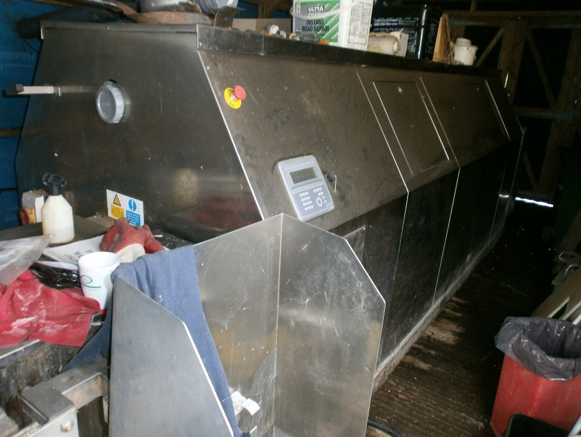

ITEM: T240 Big Hanna Composter
CONDITION: Sold as seen. Requires substantial maintainence.
CLOSING DATE:
5pm, Monday 7th December 2015

For more information, or to arrange an inspection of the item, please contact infrastructure@scilly.gov.uk or call 01720 424316
PLEASE NOTE: The Council of the Isles of Scilly makes no representations or warranties as to the fitness for purpose of the item(s) purchased. The purchaser is understood to have inspected the goods to make their own assessment as to their condition and suitability for future use.
TO BE COMPLETED BY BIDDER:
NAME:
ADDRESS:

TELEPHONE:
EMAIL:
BID AMOUNT £
Final bid is subject to contract.
SIGNATURE: DATE:

