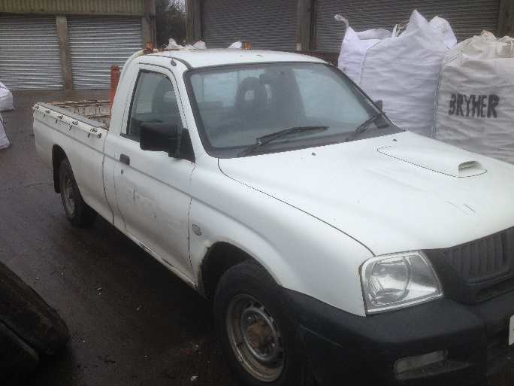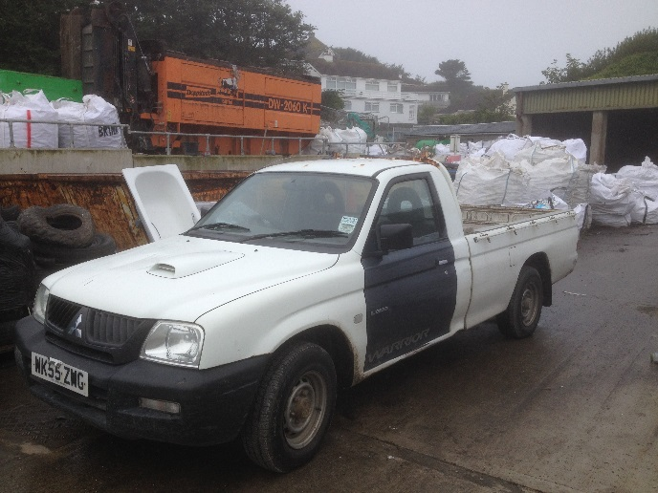
ITEM: Mitsubishi L200-4-work pick up.

CONDITION: Sold as seen. Old vehicle, signs of wear and tear to bodywork, mechanically sound.

CLOSING DATE: 5pm, Thursday 26th October 2017

For more information, or to arrange an inspection of the item, please contact infrastructure@scilly.gov.uk or call 01720 424316

PLEASE NOTE: The Council of the Isles of Scilly makes no representations or warranties as to the fitness for purpose of the item(s) purchased. The purchaser is understood to have inspected the goods to make their own assessment as to their condition and suitability for future use.

TO BE COMPLETED BY BIDDER:
NAME:
ADDRESS:

TELEPHONE:
EMAIL:
BID AMOUNT £
Final bid is subject to contract.
SIGNATURE: DATE:

