ITEM: Trailer
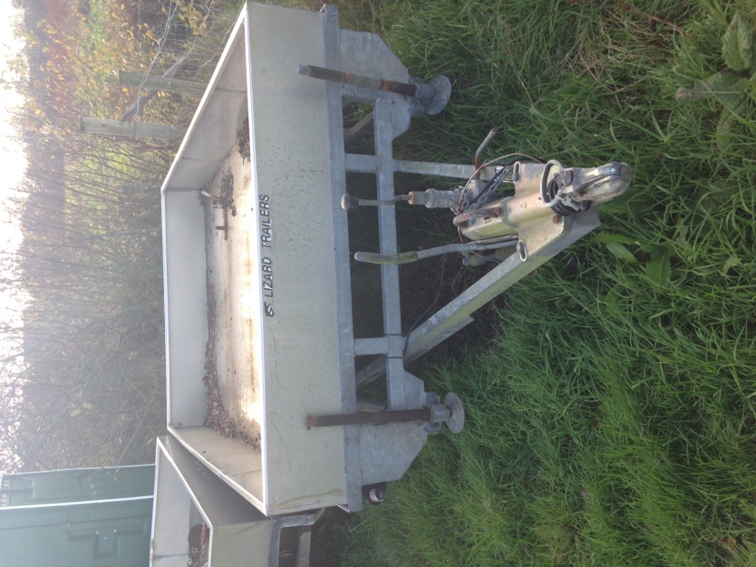
There are 2 identical trailers for sale. You should submit your bid for the appropriate numbered trailer ( Trailer 1/ Trailer 2)If you are intending to submit a bid for both trailers, you must submit a separate bid for each one.
CONDITION: In working order.
CLOSING DATE: 31st December 2014
For more information, or to arrange an inspection of the item, please contact infrastructure@scilly.gov.uk
PLEASE NOTE: The Council of the Isles of Scilly makes no representations or warranties as to the fitness for purpose of the item(s) purchased. The purchaser is understood to have inspected the goods to make their own assessment as to their condition and suitability for future use.

TO BE COMPLETED BY BIDDER:

NAME:
ADDRESS:

TELEPHONE:
EMAIL:

BID AMOUNT £
Final bid is subject to contract.
SIGNATURE: DATE:

