Delegated Report

Application Number: P/15/017/DISCON
Recommendation: PER/DEL
Date: 11th March 2015
8 Week Target: 01.04.2015
Neighbours Notified on: Expiry Date:
Site Address: Well Cross Yard, Wellcross
Island: St Mary’s
Development Proposed: Application to discharge conditions 5 (details of boundary walls), 8 (sustainable design measures), 9 (rooflights), 10 (roof coverings), 11 (lime mortar specification), 13 (historic building record), 16 (rainwater goods), 17 (boundary treatments) and 18 (building ventilation) of P/14/026/FUL and condition 4 (details of boundary walls) of P/14/027/LBC for approved residential development at Well Cross Yard.

Condition | Information Submitted | Assessment
P/14/026/FUL
Condition 5
Prior to the commencement of any works to any of the boundary walls of the application site with neighbouring properties details of such works shall be submitted to and approved in writing by the Local Planning Authority. Thereafter the works shall be carried out in strict accordance with the approved details. | This condition has been written to allow work to commence on site and for a party wall agreement to be entered into between the applicant and neighbouring properties in relation to works to any party/boundary walls.  It is understood that a Party Wall Agreement is not actually required and the agent has advised that once the existing roofing material has been removed, the debris has been cleaned out and the structures have been secured and assessed proposals will be submitted about what works need to take place on the boundary walls.  Update (12.03.2015)  The Agent has submitted details in relation to the boundary wall with Lemon Hall. This states that the top of the stone boundary wall will be capped off with an eminently natural hydraulic lime (NHL5). The mortar joints within the walls will be raked out by hand where mortar is lose back to a firm base and will be repointed with a moderately natural hydraulic lime (NHL3.5). This will be finished with a churn brush. The existing blockwork gable end, that faces Lemon Hall, will be taken down to wall plate height and will receive the same NHL5 cap, as per the rest of the boundary wall. The rest of the boundary walls with neighbouring properties will be re-pointed only, in accordance with the NHL3.5 mortar.  The Agent has confirmed no party wall agreement was required. | As exploratory investigative works only are to take place to secure the walls, I consider this is acceptable. I note that full details about any formal alterations and works to these walls will be submitted before those works are carried out.  Update (12.03.2015)  The use of an eminently hydraulic lime based mortar is an acceptable strength lime mortar for capping off. This will prevent water from penetrating the wall and causing deterioration of the solid masonry construction. The use of a moderately hydraulic lime based mortar for the repointing of the walls is an appropriate method for repointing a solid masonry wall.  The removal of the block work wall to wall plate height is similarly considered acceptable.  A site visit has been undertaken to inspect a sample area of pointing and to look at the specification/mix of lime mortar.  The removal of the block work wall to wall plate height is similarly considered acceptable.  A site visit has been undertaken to inspect a sample area of pointing and to look at the specification/mix of lime mortar.  This was made with the planning officer and the contractor Martin Quick on 23rd March. The pointing was found to be acceptable and the boundary wall with Lemon Cross had been adequately finished.
Condition 8
A detailed scheme indicating the sustainable design measures to be incorporated into the proposal shall be agreed in writing with the Local Planning Authority and should include water conservation and renewable energy generation. The scheme shall include precise details of the solar panels, including their positioning so as to maximize their efficiency and effectiveness. The sustainable design scheme shall be implemented in strict accordance with the details as agreed prior to the occupation of the development hereby permitted. As soon as the solar panels hereby approved are no longer required for their intended purpose, they shall be removed from the building and the roof reinstated to its former condition. | The agent has advised the council that a full package will be issued to the council under a separate submission. They note, however that rainwater will be collected from roofs into butts for use in external areas to reduce water consumption. | It is considered that without full details of numbers and positions of water collection butts and full details of solar panels there is insufficient information on which to discharge this condition. However this is not a pre-commencement condition and providing these details are submitted and agreed prior to the first occupation of the dwellings then works can continue on the conversion scheme.
Condition 9
Prior to the installation of rooflights hereby permitted, details of their proposed form, finishes, glazing and means/extent of opening shall be submitted to and approved in writing by the Local Planning Authority. The rooflights shall subsequently be installed in strict conformity with the approved details and shall thereafter be retained and not altered without the prior permission of the Local Planning Authority. | The Agent has confirmed that the windows will be ‘conservation’ style velux brand rooflights with one-way film and restricted opening in the size and position on the approved drawings (5484 S4k). | It is considered that as the lowest part of the window is 2 metres above ground it will not be possible to over look neighbouring properties. So whilst the amount the windows are restricted by, in terms of opening, is not specified, the fact that they are restricted is sufficient. I am satisfied that these windows will not give rise to any overlooking due to their high position. The use of the windows to the size and position specified is sufficient to discharge this condition.
Condition 10
The roof covering for the development hereby permitted shall be natural slate, a sample of which shall be submitted to and approved in writing by the Local Planning Authority and the development shall be carried out in accordance with the approved sample and be retained as such thereafter. | The Agent has submitted a ‘lugo’ slate sample of 16cm x 8cm. To demonstrate the materials for use of the roof of the approved conversions. | A lugo slate is sourced from north-west Spain. It is considered that this natural slate material is acceptable to cover the roof of the approved dwellings. The sample submitted is sufficient to discharge this condition.
Condition 11
All mortar and render constituents required in connection with the works hereby permitted shall be lime based to match the existing. | The Agent has stated that the mortar and concrete will be a natural hydraulic lime with gritty sand. The grade will be 3.5 for bedding, pointing and re-pointing and grade 5 for copings. | It is considered that the specification is unclear in terms of the mix or whether any part will be cement or other unknown pozzolanic ingredients. The ‘brand’ of natural hydraulic lime is similarly unspecified. Finally it is unclear why in this location a nhl 5 would be required for copings. NHL 5 is an eminently hydraulic strength lime required in particularly damp areas. The site is not particularly exposed and as such it is difficult to understand why this has been specified.  Having said that this condition does not require discharging they have to comply with the requirement and use a lime based mortar to match the existing lime on the property. In this respect the use of the lime as specified is considered acceptable
Condition 13
No works shall be carried out on site, until a detailed photographic record of the existing buildings to be converted, both interior and exterior is undertaken and a brief report (to an English Heritage level 2-3 record) produced. A copy of the photographic record and a report shall be deposited with the Local Planning Authority and with the Historic Environment Service of Cornwall Council. | The Historic Building Record report has been completed by RTP Chartered Surveyors. It is compiled to a EH Level 2 standard and the guidance issued by English Heritage: “Understanding Historic Buildings: A Guide to Good Recording Practice”. | I consider the information submitted, which has been provided to the Council and the Historic Environment Service of Cornwall Council, is sufficient to record the details of the ‘existing’ structures at this site. The condition therefore has been satisfied.
Condition 16
The rainwater goods to be used on the development hereby approved shall be black half round cast effect. | The Agent has confirmed that a black Elegance Cast Iron Effect guttering and down pipes will be used on the conversion. | The condition does not require discharging only compliance. I am satisfied that the developer will comply with the requirements of this condition if the rwg’s specified are used.
Condition 17
Prior to the first use of the development hereby permitted, screen walling/fencing/planting shall be erected on the southern boundary of the site in accordance with details to be submitted to and approved by the Local Planning Authority. Thereafter the approved boundary walling/fencing/planting shall be retained and shall not be altered. | The Agent has stated that this will be reviewed and a proposal made once the roof covering has been removed and the condition of existing structures assessed. | As this is not a pre-commencement condition and providing they submit these details before first ‘using’ the site I consider it is acceptable to submit these details at a later date.
Condition 18
If mechanical ventilation is required in connection with the approved dwellings, prior to its installation, the details including precise location, shall be submitted to and approved in writing with the Local Planning Authority. The installation of the mechanical ventilation shall be carried out in strict accordance with the approved details. | The Agent has stated that a full package will be issued under a separate submission. | As this is not a pre-commencement condition I am satisfied that this information can be provided, if required, at a later date.
P/14/027/LBC
Condition 4
Prior to the commencement of any works to any of the boundary walls of the application site with neighbouring properties details of such works shall be submitted to and approved in writing by the Local Planning Authority. Thereafter the works shall be carried out in strict accordance with the approved details. | This condition has been written to allow work to commence on site and for a party wall agreement to be entered into between the applicant and neighbouring properties in relation to works to any party/boundary walls.  It is understood that a Party Wall Agreement is not actually required and the agent has advised that once the existing roofing material has been removed, the debris has been cleaned out and the structures have been secured and assessed proposals will be submitted about what works need to take place on the boundary walls.  Update (12.03.2015)  The Agent has submitted details in relation to the boundary wall with Lemon Hall. This states that the top of the stone boundary wall will be capped off with an eminently natural hydraulic lime (NHL5). The mortar joints within the walls will be raked out by hand where mortar is lose back to a firm base and will be repointed with a moderately natural hydraulic lime (NHL3.5). This will be finished with a churn brush. The existing blockwork gable end, that faces Lemon Hall, will be taken down to wall plate height and will receive the same NHL5 cap, as per the rest of the boundary wall. The rest of the boundary walls with neighbouring properties will be re-pointed only, in accordance with the NHL3.5 mortar.  The Agent has confirmed no party wall agreement was required. | As exploratory investigative works only are to take place to secure the walls, I consider this is acceptable. I note that full details about any formal alterations and works to these walls will be submitted before those works are carried out.  Update (12.03.2015)  The use of an eminently hydraulic lime based mortar is an acceptable strength lime mortar for capping off. This will prevent water from penetrating the wall and causing deterioration of the solid masonry construction. The use of a moderately hydraulic lime based mortar for the repointing of the walls is an appropriate method for repointing a solid masonry wall.  The removal of the block work wall to wall plate height is similarly considered acceptable.  A site visit has been undertaken to inspect a sample area of pointing and to look at the specification/mix of lime mortar.  This was made with the planning officer and the contractor Martin Quick on 23rd March. The pointing was found to be acceptable and the boundary wall with Lemon Cross had been adequately finished.

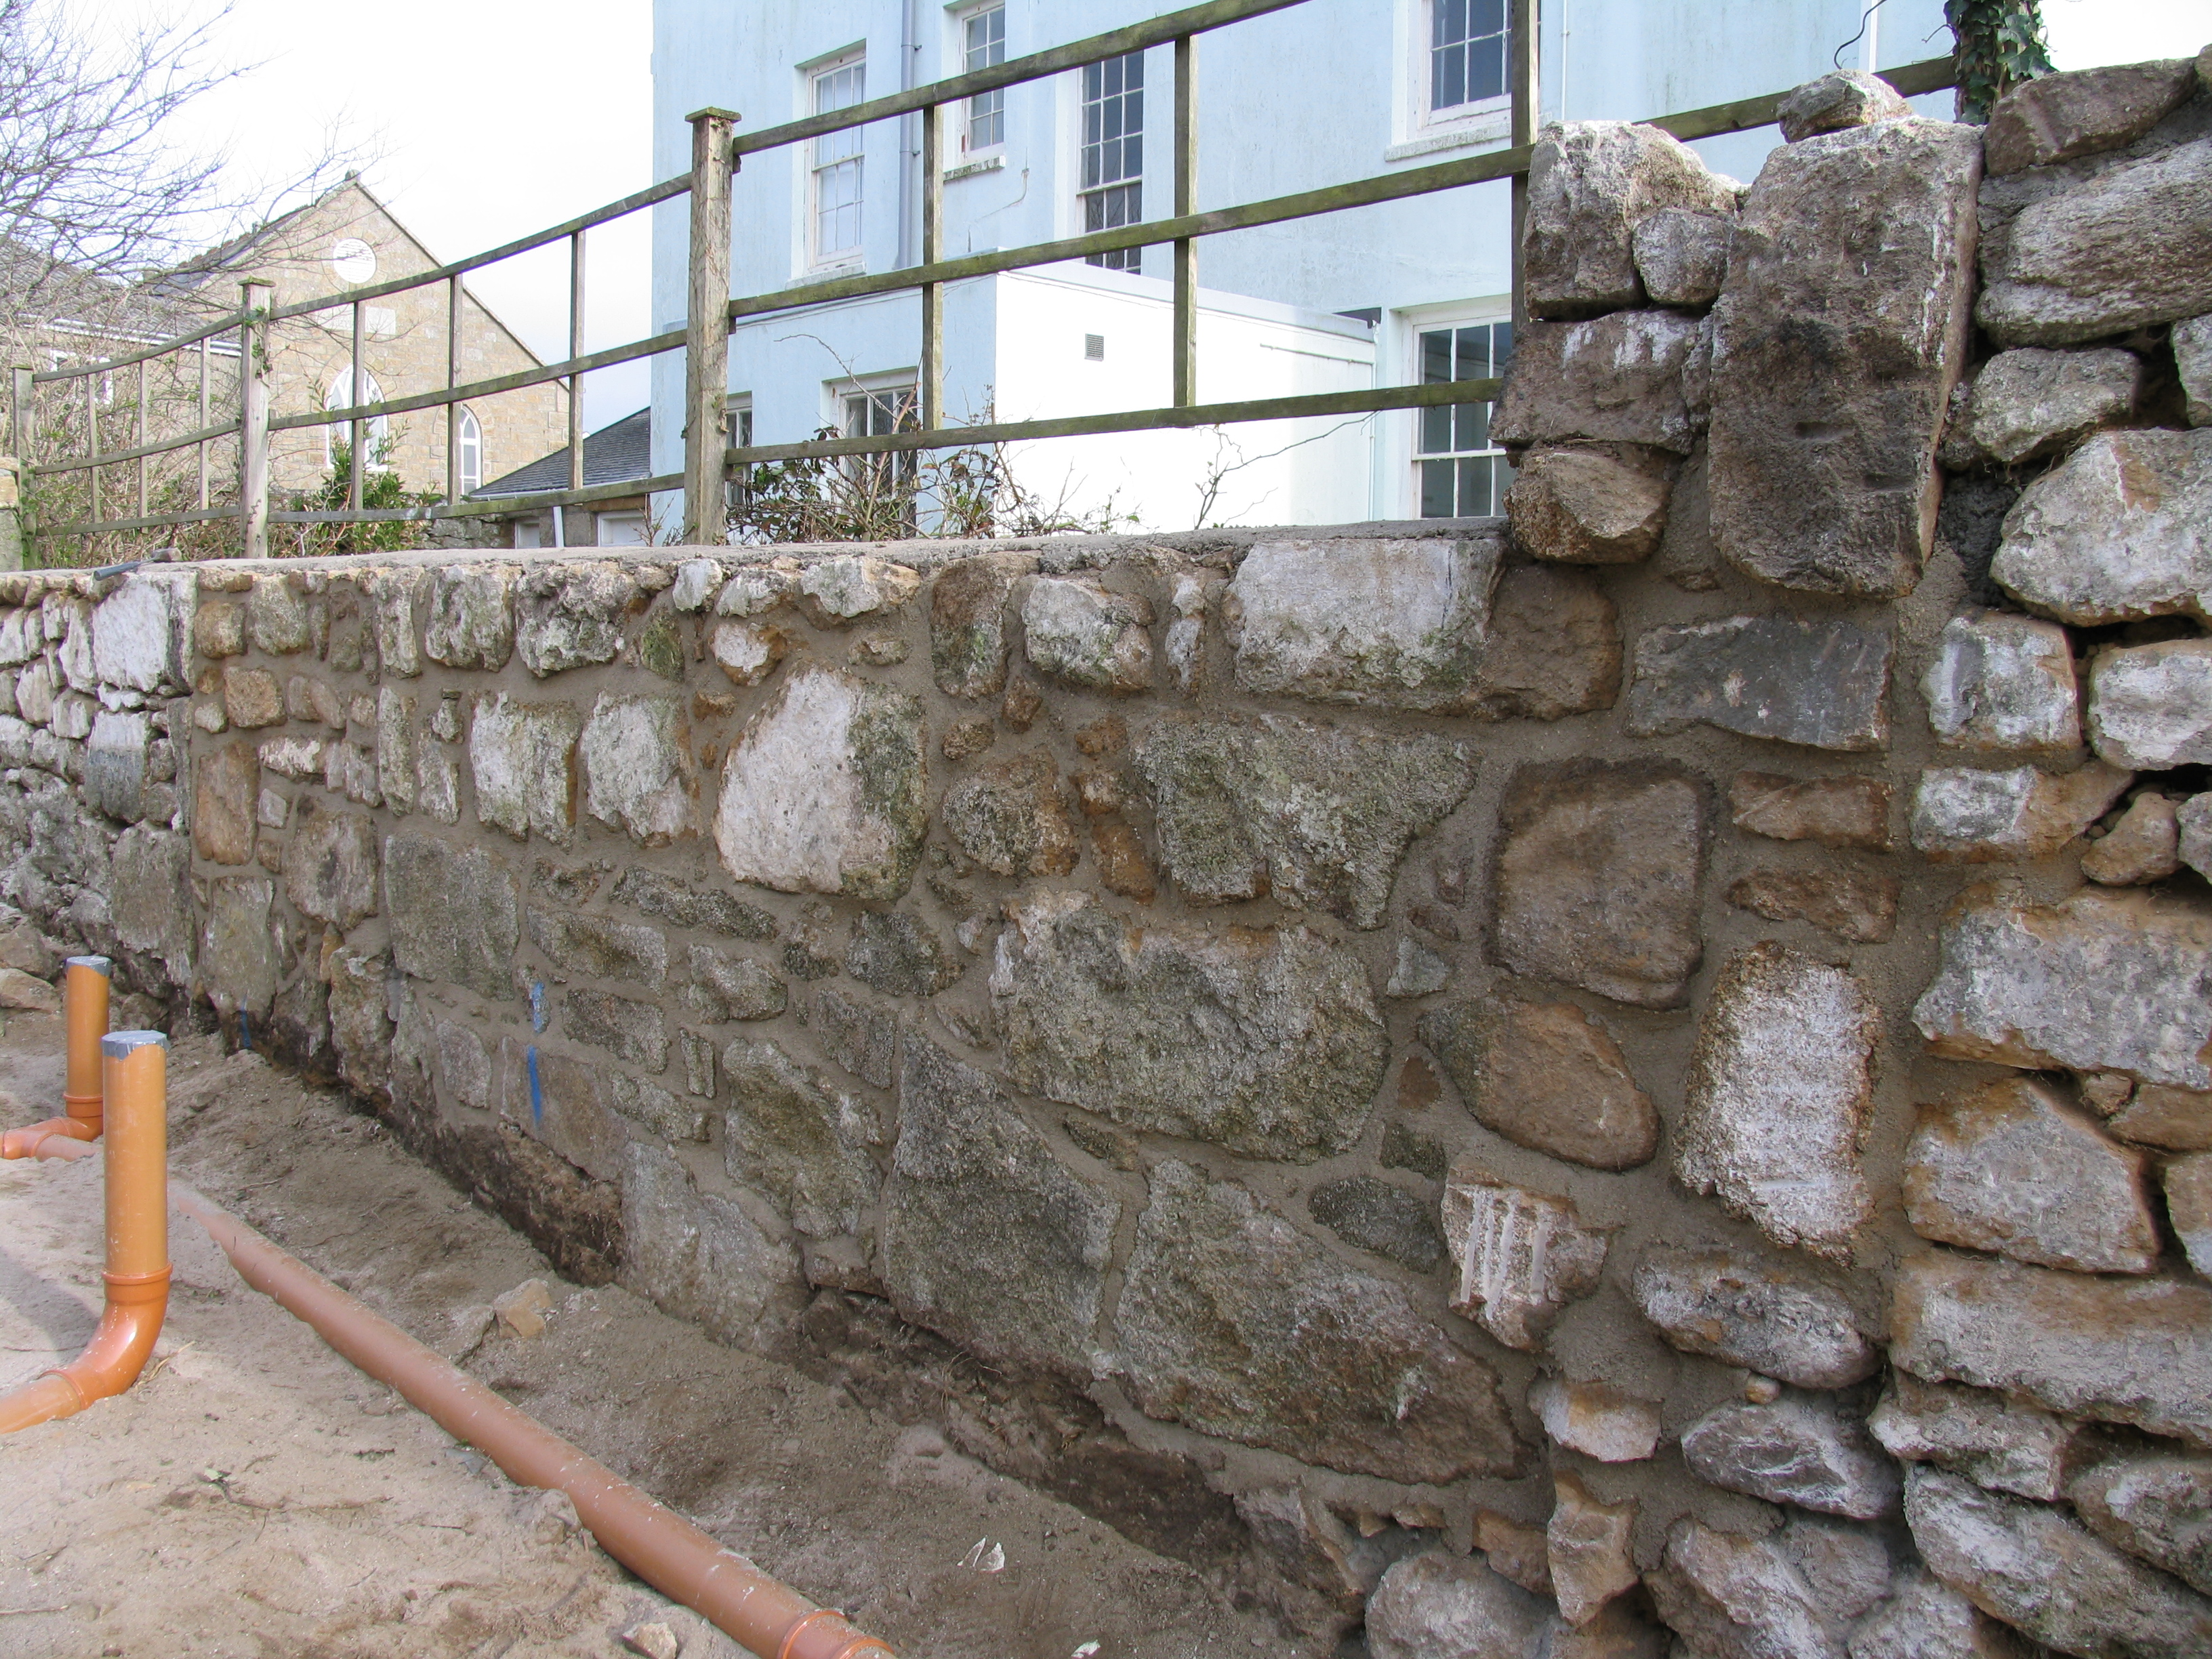

Signed Date:

